Andrea's Pace-Setting Angels

$300,00 Circle of Achievement Unit
Chevy Equinox Unit

February 2011 Newsletter (December 2010 News)
Andrea Pace Unit 0154 -- 4206 Southfield Road, Ellicott City, Maryland 21042
Phone: (410) 465-4442 or 1-800-863-2463; FAX: (410) 313-9294;
Cell Phone: (443) 980-7353; Email: andrea@andreapace.com
Web site for Andrea’s Consultants: http://www.andreapace.com (Password: 0154)
Customer Website: http://www.marykay.com/andreapace

Welcome Back -- Reinstated Consultants
Sandy Flores (Rio Rancho. NM) Kathi Heering (Danbury, CT)
Virginia Jones (Trinidad, TX) Karen Meno (Rockwall, TX)

Dear Angels,
Oh I am soooo excited. I have loads of information for you.
- If you are not receiving my emails, be sure and send me an email and tell me your email address. This is so important as this will allow you to receive information immediately. Also anytime you change your email address – again – let me knowl.
- Mary Kay will Ship an Order to Your Customers for just $5.00 on any order under $100 retail. Orders over $100 the cost will be $8.75. This includes a FREE copy of The Look or two Free Samplers in every order. Say goodbye to costly packing supplies and long mailing lines. Why Wait? Immediately ship products you may not have in inventory. Star Consultants can do this now, but starting March 16, 2011, every Active Independent Beauty Consultants can have this service. You need to sign up for the ProPay Account. This is a must anyway as this also allows you to take credit cards from your customers.
- At the end of January, you will be able to get your 2010 Income Advisory Statement under My Business. Click on Reports. Then Click on Income Advisory Statement. It will list your Recruiting commissions and wholesale orders for each month in 2010.
- What is your Foundation Fit? To help your customers choose the right foundation for them, call each of your customers and set up appointments with them to go over this survey and complete a Stripe Test on each one. When you hold up the Foundation Finder Tool (#043431 Section 2 $5.00) you select the shade that disappears on her skin.
- EVERYONE WHO DOES A Strip Test on 30 Faces will receive a fabulous prize from me. (You Will Love the Prize and your Customers will love you for helping them select the correct shade.)
- Ask these 3 question of everyone: A. What is the most important thing you want from your foundation? B. What is your skin type? C. What is the finish you want after? The answers to these questions will help determine which formula is best for that person.
Love you, Andrea

December 2010 Scoreboard

Consultants Ordering In December 2010 Queen Nancy Grissom -- $963

Sherri Allen
Delma Aranda
Lynda Boland
Donna Canada
LaJoyce Cannon
Christine Castioni
Kay Childers
Patricia Colbert
Donna Cox
Candace Entingh
Becky Farris
Sandy Flores
Joyce Foster
Beryl Greenawalt
Nancy Grissom
Bee Hamlin
Eileen Hanson
Jackie Hatcher
Kathi Heering
Ruby Hulett
Phyllis Jones
Virginia Jones
Barbara Kelly
Margie Kitten
Judi LILES
Nina Mack
Gloria McCutcheon
Karen Meno
Andrea Pace
Nancy Sweet
Claudia Tufano
Joker Ward
B.J. Watson
Judith Weiner
Mary Welter
Julie White

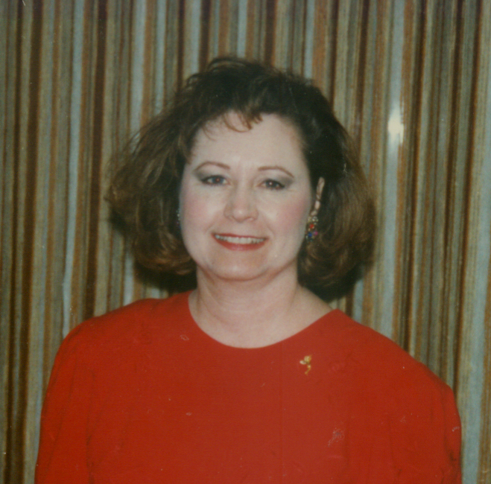

Eileen Hanson -- $899
Donna Cox -- $756
Judi Liles -- $664

Andrea Pace -- $720

Court of Sharing (to 11/30/2010)
Patricia Colbert -- 1
Beryl Greenawalt – 1
Judi Liles -- 1

Year to Date Retail Production thru 12/31/2010
1 Judi Liles $9,211.50
2 Kay Childers $9,095.00
3 Phyllis A. Jones $8,465.50
4 Eileen Hanson $5,922.50
5 Jackie Hatcher $5,021.00
6 Nancy G. Grissom $4,656.50
7 Ruth H. Hise $4,538.00
8 Dolores M. Montoya $4,519.00
9 Donna Canada $4,315.00
10 Christine T Castioni $4,031.00
11 Gloria K. McCutcheon $3,978.50
12 Patricia R. Colbert $3,415.50
13 Donna G. Cox $3,060.00
14 Candace D. Entingh $2,854.00
15 Beryl A. Greenawalt $2,594.50
16 Michelle E. Allen $2,545.00
17 Mary L. Welter $2,516.50
18 Joker Ward $2,359.00
19 Teresa G. Rubio $2,258.00
20 Becky L. Farris $2,031.50

Andrea Pace $14,063.00
Consultants with
December Recruiter Commissions

13% Recruiter Commission Level
Andrea Pace
Judi Liles

4% Recruiter Commission Level
Christine T Castioni
Jackie Hatcher
Ruby F. Hulett
Donna Canada
Beryl A. Greenawalt
Phyllis A. Jones
Sharon A. Edwards
Candace D. Entingh

Total Unit Retail Production
December 2010 -- $24,619
Seminar Year -- $176,094

Recruiters and their Teams (as of December 31, 2010)

Future Sales Director
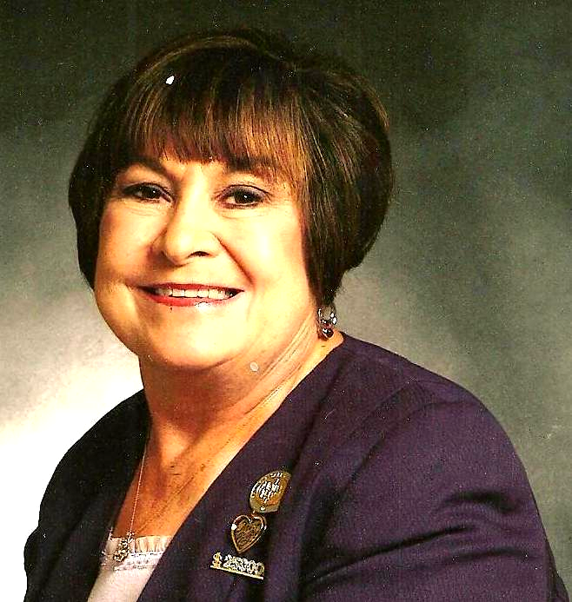
Recruiter: Judi Liles
Helen Bearden
LaJoyce M. Cannon
Jody O. Colwell
Brenda Green
Virginia L. Jones
Barbara Kelly
Robbie F. Litzman
B.J. Watson
* Cheri Akers
* Jo L. Henderson
* Martha J. Lange
* Bobbie L. Merritt
* Carol F. Sanders
* Melba J. Williams

Star Team Builders 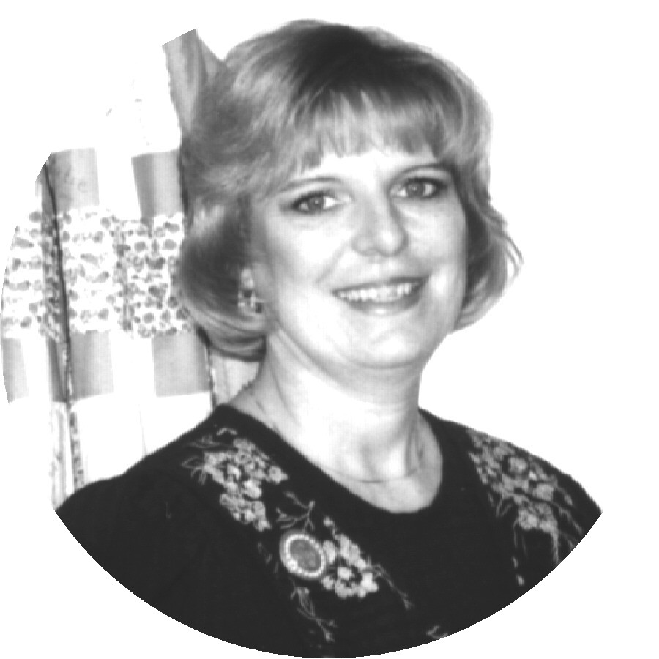
Recruiter: Donna Canada
Sherri L. Allen
Donna K. Gray
Linda S. Richardson
Teresa G. Rubio
* Cody Hanagan

Star Team Builders

Recruiter: Jackie Hatcher
Sandy Flores
Eileen Hanson
Dolores M. Montoya
* Cruz P. Torres

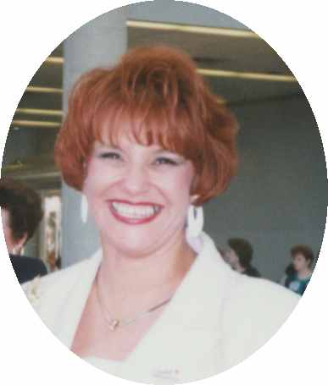
Recruiter: Christine T. Castion
Sandy Flores
Eileen Hanson
Dolores M. Montoya
* Cruz P. Torres

- = inactive Consultant

Senior Consultants
Recruiter: Beryl A. Greenawalt
Bee A. Hamlin
* Lilian Alade
* Sharon L. Dixon
* Nancy L. Norris
* Clola M. Robinson

Recruiter: Bonnie Montgomery
Nancy G. Grissom
Doreta Higginbotham

Recruiter: Candace D. Entingh
Tena K. McElvain
Mary L. Welter

Recruiter: Cheri Akers
Karen R. Meno
* Pamela White

Recruiter: Delma C. Aranda
Pat Carrasco

Recruiter: Helen Bearden
Ruth H. Hise
Kaye Richardson

Recruiter: Kay Childers
Linda King

Recruiter: Lynda I. Boland
Beverly L. Guthrie

Recruiter: Phyllis A. Jones
Christy Fagan
Margie J. Kitten
* Ellen H. Wallace

Recruiter: Ruby F. Hulett
Phyllis A. Jones

Recruiter: Sharon A. Edwards
Julie K. White
* Bonnie L. Hobson

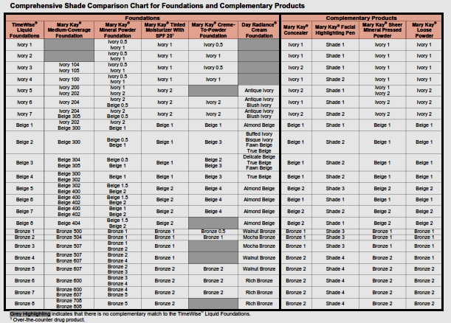
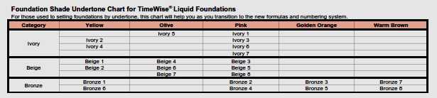

All of the charts in this newsletter are on Mary Kay Intouch. Just click on the “Save the Nation with Foundation” icon in the Action Items section. Links to all information and charts on Foundations in this newsletter (& a lot more) will be on the left side of the page that comes up when you click on “Save the Nation with Foundation.”
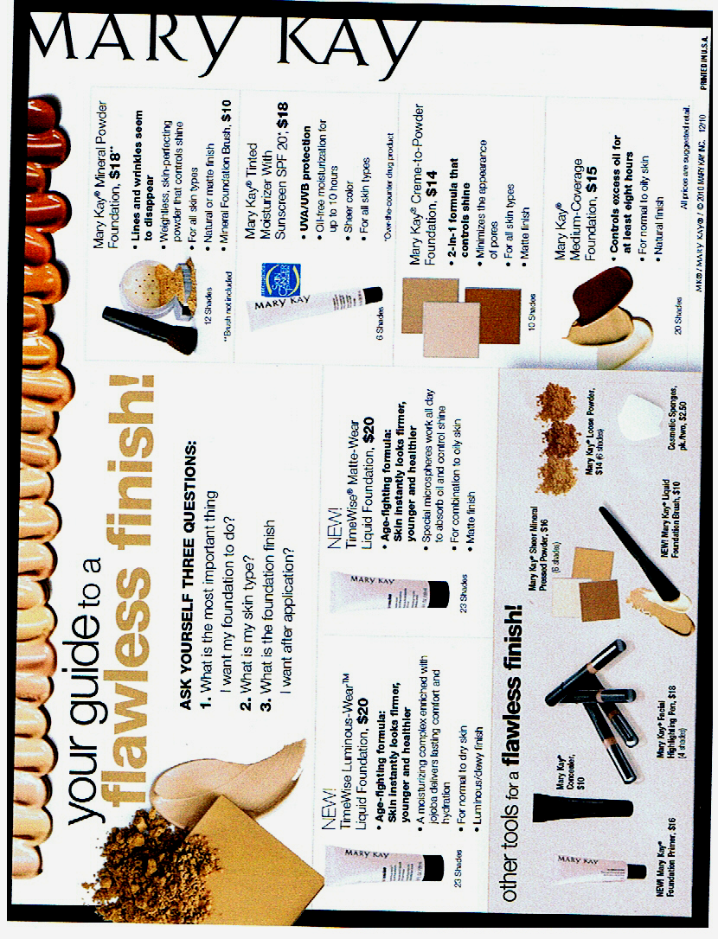

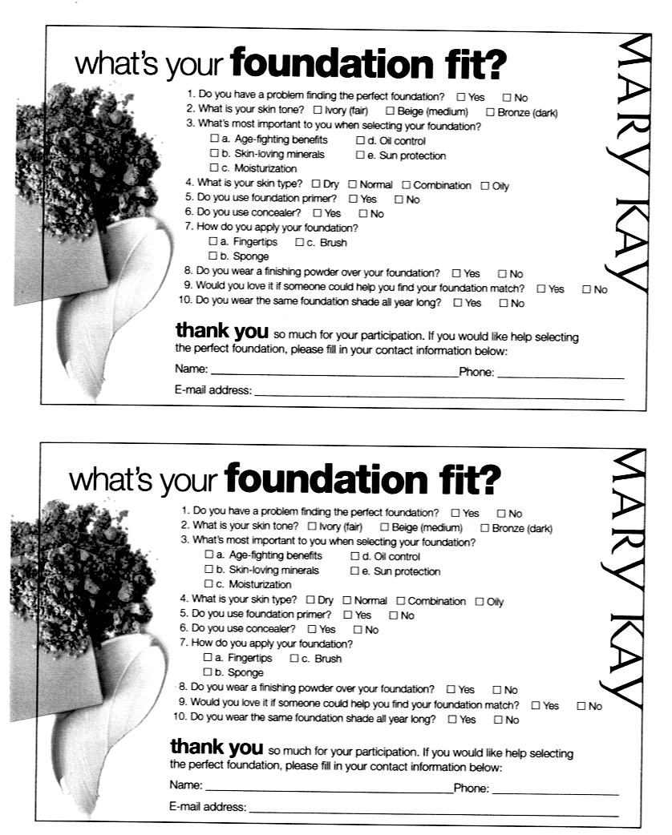

The Age Difference
( Many thanks to Diane Autry for sharing and Alice Pirola for writing)
Ever feel as though you’re just not connecting with a customer or prospective customer. Wonder whether it is you or her? Maybe you’re just caught in “The Age Difference!” Never before have we had such distinct age groups of customers – the 20 year olds, The inbetweeners, the Baby Boomers and the Silver sirens. AND – they all communicate in different ways and through different medial.

Today’s beauty consultant has to be ever so more mindful of how her dress, her style, her haircut, her nails and her words translate to the women in front of her. Silver sirens are not loving purple hair streaks and jeans with holes in them. 20 year olds, on the other hand, are all about fads, what the stars are doing and texting you to tell you about it.

At this point let me remind you there are exceptions to the rule and that these are generalities but they can really help you get a handle on why people are not answering your calls or taking time to meet with you.

Using age 35 as a dividing point, let’s look at some basic characteristics:
Age 35 and Under: Usually are energetic, have lots of stamina, are fresh, moldable and excited.
Age 35 and Older: Usually are mature, professional, loyal, have more money to spend and a bigger circle of influence.

And here’s a “Compare and Contrast” chart to help you understand them more.

Age 35 and Under
Speak Fast
Dress more casual and in today’s fashion
Prefer short, quick appointments w/no 2nd appt.
Spontaneous
Fun/Fast appointments
Don’t expect RSVPs, explanation, little loyalty
Less $$/more purchases on the spur of the minute
As a team member, must have immediate results (like in the first week) or they are gone

The Age Difference (continued)

35 and Older
Speak slower
Wear a “uniform” – pant suits, matching sweaters
Like to build a relationship. Respond to layering
Planned
One hour or more appointments
Will RSVP, will tell you why they can/can’t, some loyalty built over time
More $$, more obligations for their money
As a team member, look for results in the first month, or they become disenchanted

Thinking about all the way you have to communicate with customers, prospects and team members, use this chart to help you focus your communication for the best results.

35 and Under
Email, Face book, Twitter, and Cell Phone
Customer Newsletter, Post Carads
Birthday Club, Text Messages, Web Site
PCP (if they are settled)

35 and Older
Facebook (limited), Cell Phone
Home Answering Machine
Customer Newsletter
Personal Phone Calls, Birthday Club
Web Site, Post Cards, PCP

Now you can stop thinking it’s “You” and know that maybe you were just treating
every one the same and in today’s market that just doesn’t work. One size does not fit all, but with these clues, you can be so much more successful in your contacts.


February 2011 Prize Promotion
“Pandora” Look-a-like Bracelet & Beads
(Inspired by Pandora Bracelets. Bead selection will vary from above pictured example.)
1 Bead 2 Beads 3 Beads 4 Beads 5 Beads
$250 Whls. $400 Whls. $600 Whls. $800 Whls. $1,000 Whls.
ALSO
Receive a bead for each active team member you bring in. (Active = $200 whls. order in the same month as her agreement went in.

Receive 3 Beads for Completing Star Consultant by March 15, 2011.
Have you seen these EXPENSIVE but beautiful bracelets? Would you LOVE to have your own? Well, now you can! Starting in the month of October, you can win your bracelet and begin to fill it up with these fabulous beads throughout this Seminar year. WOW! Build – A – Bracelet! Build – A – Business!
-Keep a record of your Shows or Parties you Hold this Seminar Year.
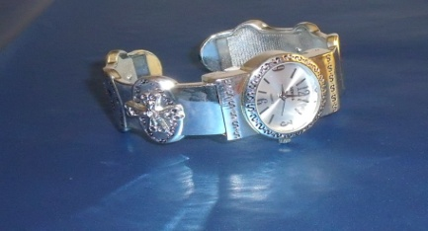
On holding your 10th Show, you will receive this beautiful Silver Inspirational Bracelet Watch. Just do this in this Seminar Year.

Let’s all help Ryan Rogers, Mary Kay’s Grandson, reach our company Goal of 5 Billion in Sales by 2013. All you have to do is just call me and say “I DID IT!”

$800+ Wholesale –4 Beads with Bracelet - Nancy Grissom and Eileen Hanson
$600+ Wholesale – 3 Beads with Bracelet – Donna Cox and Judi Liles
$400 Wholesale – 2 Beads with Bracelet – Delma Aranda, Jackie Hatcher, Phyllis Jones,
Gloria McCutcheon, and Joker Ward
$250 Wholesale – 1 Bead with Bracelet – Sherri Allen, Donna Canada, LaJoyce Cannon,
Christine Castioni, Kay Childers, Candace Entingh, Sandy Flores, Bee Hamlin, and Claudia Tufano


Top Ten In Sales by June 30, 2011 will Win a Sweet Success Trinket Box
The hand-painted porcelain box opens to reveal a yummy place to hide your little keepsakes. The top is sprinkled with clear crystal stones. The gold-tone clasp features an MK logo.


Our Queen of Sales by June 30, 2011 will win a Beautiful Reflection Necklace and Earrings. Angular shapes are clearly on-trend, and these pale peach and smoky lavender glass stones dazzle framed by a gold tone bezel setting. The necklace measures 16 ½”. An extender adds 3”. The matching earrings with closed French wire backs are available for pierced ears only.

Happy Birthday
February Day
Patricia R. Hopkins 1
Patricia A. Holt 2
Virginia L. Jones 2
Barbara Kelly 2
LaJoyce M. Cannon 4
Bobbie L. Merritt 8
Becky L. Farris 15
Marilyn Nguty-Nkeng 20
Billie J. Beckham 27

Mary Kay Anniversary
February Years
Jackie Hatcher 32
Melba J. Williams 29
Cheri Akers 24
Gloria K. McCutcheon 23
Patricia R. Colbert 13
Carol F. Sanders 1
C R. Akins 1

Your Guide to What’s Inside
Welcome / Dear Angels (page1)
December Scoreboard (page 2)
Recruiter & their Teams (page 3)
Comprehensive Shade Chart (p. 4)
Your Flawless Finish Guide (p. 5)
What’s

Your Foundation Fit? (p.6)
The Age Difference (pages 7- 8)
February Promotion (page 9)
Birthdays & Anniversaries (p. 10)

Note from NSD Emeritis Marilyn Welle Villela

I was recently asked why, if this opportunity is so great, EVERYONE did not drive a Cadillac, win trips or enjoy financial abundance. My response was so easy, so quick and so simple it surprised even me. I said, “Without a dream, you can’t have one come true. However, it takes courage to dream, courage to work and courage to continue during times of adversity. When a woman steps out in faith to accomplish great things, she is empowered and her efforts are blessed! Not everyone is willing to persist. That’s the difference.

Andrea Pace, Future Executive Senior Sales Director
4206 Southfield Road
Ellicott City, Maryland 21042-5906
(410) 465-4442 or 1-800-863-2463
Fax No. (410) 313-9294; Cell Phone: (443) 980-7353
E-Mail Address – andrea@andreapace.com
Web Site for Andrea’s Consultants:
http://www.andreapace.com
Customer Website:
http://www.marykay.com/andreapace

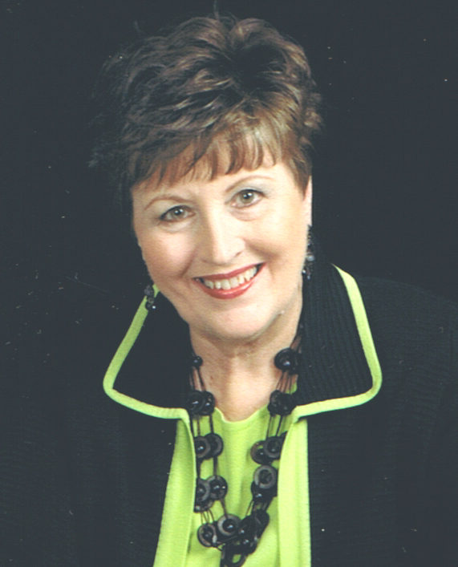

Psalm 117:1-2 - “All you nations, praise the Lord. All you people, praise him because the Lord loves us very much, and his truth is everlasting. Praise the Lord!”

