Andrea's Pace-Setting Angels

$300,00 Circle of Achievement Unit
Chevy Equinox Unit

October 2010 Newsletter (August 2010 News)
Andrea Pace Unit 0154 -- 4206 Southfield Road, Ellicott City, Maryland 21042
Phone: (410) 465-4442 or 1-800-863-2463; FAX: (410) 313-9294;
Cell Phone: (443) 980-7353; Email: andrea@andreapace.com
Web site for Andrea’s Consultants: http://www.andreapace.com (Password: 0154)
Customer Website: http://www.marykay.com/andreapace

Welcome Back -- Reinstated Consultants
Pamela White (Rockwall, TX)

Hall of Fame for October 2010

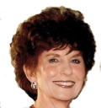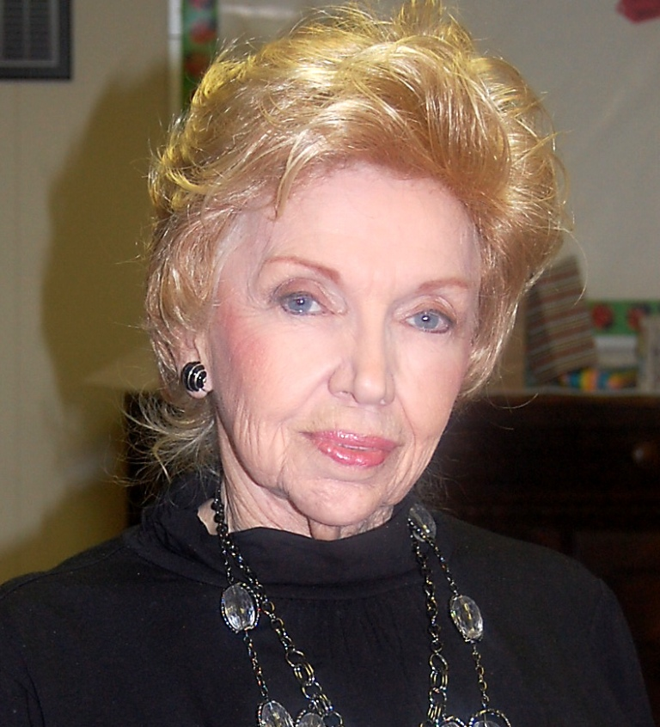
Jackie Hatcher Ruth Hise
$1,426 wholesale production $1,124 wholesale production

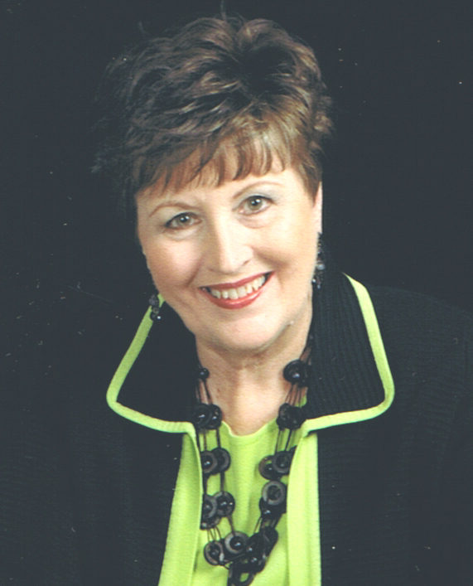
Andrea Pace
$1,543 wholesale production
August 2010 Scoreboard

Consultants Ordering In August 2010 Queen Jackie Hatcher -- $1,426

Lilian Alade
Michelle Allen
Delma Aranda
Lynda Boland
Christa Brack
Christine Castioni
Kay Childers
Patricia Colbert
Donna Cox
Sharon Dixon
Lola Duran
Candace Entingh
Becky Farris
Beryl Greenawalt
Beverly Guthrie
Bee Hamlin
Jackie Hatcher
Ruth Hise
Margot Howard
Phyllis Jones
Barbara Kelly
Margie Kitten
Martha Lange
Judi Liles
Gloria McCutcheon
Bonnie Montgomery
Dolores Montoya
Jana Morgan
Bonnie Morrison
Andrea Pace
Clola Robinson
Teresa Rubio
Carol Sanders
Carolyn Simns
Debra Southerland
Nancy Sweet
Claudia Tufano
Susan Wesner
Pamela White

Ruth Hise -- $1,124
Judi Liles -- $847
Beryl Greenawalt -- $605

Andrea Pace -- $1,593

Court of Sharing (Year to 8/31/2010)

Beryl Greenawalt - 1

Year to Date Retail Production thru 8/31/2010
1 Judi Liles $5,552.00
2 Kay Childers $3,774.00
3 Ruth H. Hise $3,442.00
4 Jackie Hatcher $2,938.50
5 Nancy G. Grissom $2,705.50
6 Eileen Hanson $2,696.50
7 Dolores M. Montoya $2,513.00
8 Phyllis A. Jones $2,411.50
9 Donna Canada $2,286.50
10 Gloria K. McCutcheon $2,266.50
11 Christine T Castioni $1,906.00
12 Beryl A. Greenawalt $1,796.00
13 Michelle E. Allen $1,729.50
14 Patricia R. Colbert $1,639.00
15 Donna G. Cox $1,533.50
16 Teresa G. Rubio $1,447.50
17 Bee A. Hamlin $1,257.50
18 Jana R. Morgan $1,226.00
19 Lola M. Duran $1,119.50
20 Candace D. Entingh $1,071.00

Andrea Pace $5,666.50
Consultants with
August Recruiter Commissions

9% Recruiter Commission Level
Judi Liles
Jackie Hatcher
Andrea Pace
Beryl A. Greenawalt

4% Recruiter Commission Level
Helen Bearden
Ruby F. Hulett
Christine T Castioni
Lynda I. Boland
Margot Howard
Donna Canada
Phyllis A. Jones
Bonnie N. Montgomery

Total Unit Retail Production
August 2010 -- $27,753
Seminar Year -- $70,588

Recruiters and their Teams (as of August 31, 2010)

Future Sales Director
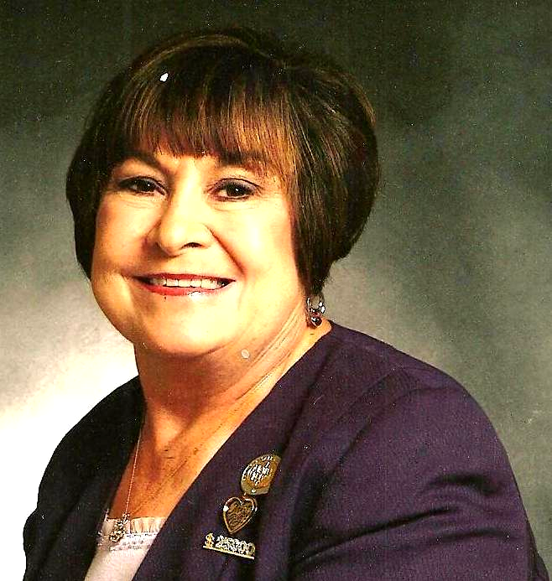
Recruiter: Judi Liles
Helen Bearden
Brandy M. Blount
LaJoyce M. Cannon
Iris Cummins
Barbara Kelly
Martha J. Lange
Carol F. Sanders
Carla A. Villyard
* Cheri Akers
* Kimberly A. Bauer
* Patricia A. Holt
* Virginia L. Jones
* Marilee Mandernach
* Bobbie L. Merritt
* B.J. Watson
* Melba J. Williams
* MaryAnn Youngblood

Team Leaders 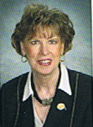
Recruiter: Beryl A. Greenawalt
Lilian Alade
Sharon L. Dixon
Bee A. Hamlin
Clola M. Robinson
Angela M. Sabourin
* Sandra Gutierrez
* Nancy L. Norris
* Crystal D. Watson

Team Leaders
Recruiter: Jackie Hatcher
Yvette A. Birch
Donna G. Cox
Joyce Johnson
Sandra L. Schillizzi
Susan C. Wesner
* Helen Westlund

Star Team Builders

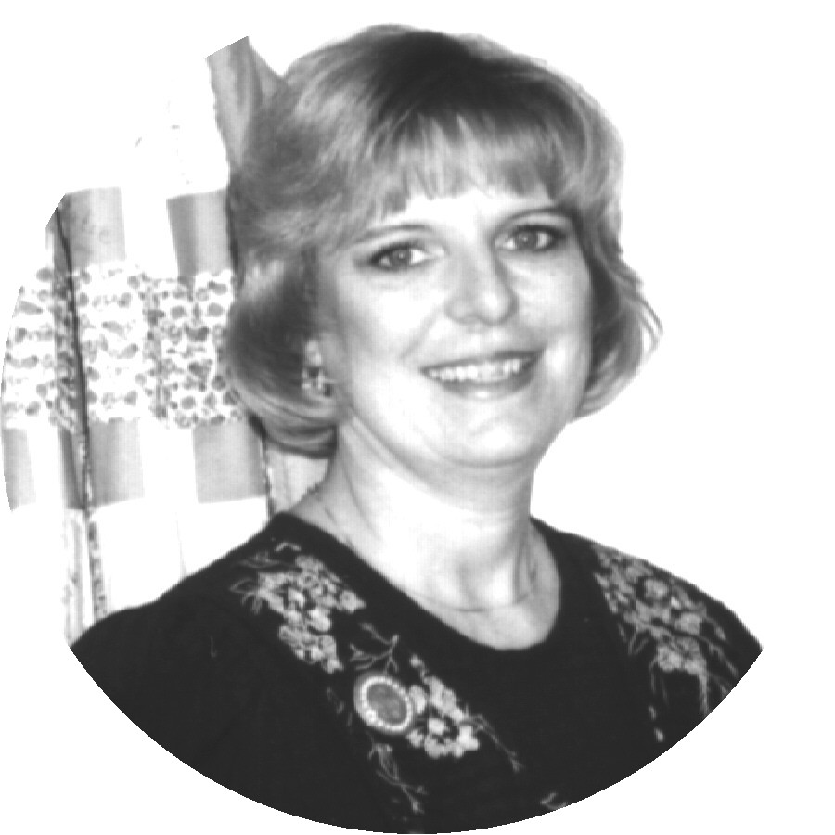
Recruiter: Donna Canada
Sherri L. Allen
Donna K. Gray
Cody Hanagan
Teresa G. Rubio
* Linda S. Richardson

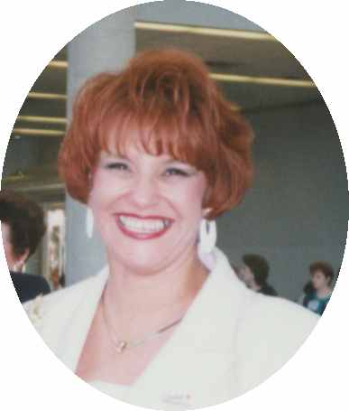
Recruiter: Christine T. Castion
Eileen Hanson
Lisa Heenan
Dolores M. Montoya
Cruz P. Torres

- = inactive Consultant
Senior Consultants
Recruiter: Bonnie Montgomery
Nancy G. Grissom
Debra D. Southerland
* Jana D. Laubscher

Recruiter: Candace D. Entingh
Mary L. Welter
* Tena K. McElvain

Recruiter: Cheri Akers
Karen R. Meno
Pamela White

Recruiter: Delma C. Aranda
Pat Carrasco

Recruiter: Eileen Hanson
Geneva D. Trujillo

Recruiter: Helen Bearden
Ruth H. Hise
Kaye Richardson

Recruiter: Lynda I. Boland
Beverly L. Guthrie

Recruiter: Margot Howard
Bonnie S. Morrison

Recruiter: Phyllis A. Jones
Christy Fagan
Margie J. Kitten

Recruiter: Ruby F. Hulett
Phyllis A. Jones

Recruiter: Sharon A. Edwards
Julie K. White

Andrea Pace
Ruby Star
$2419 wholesale

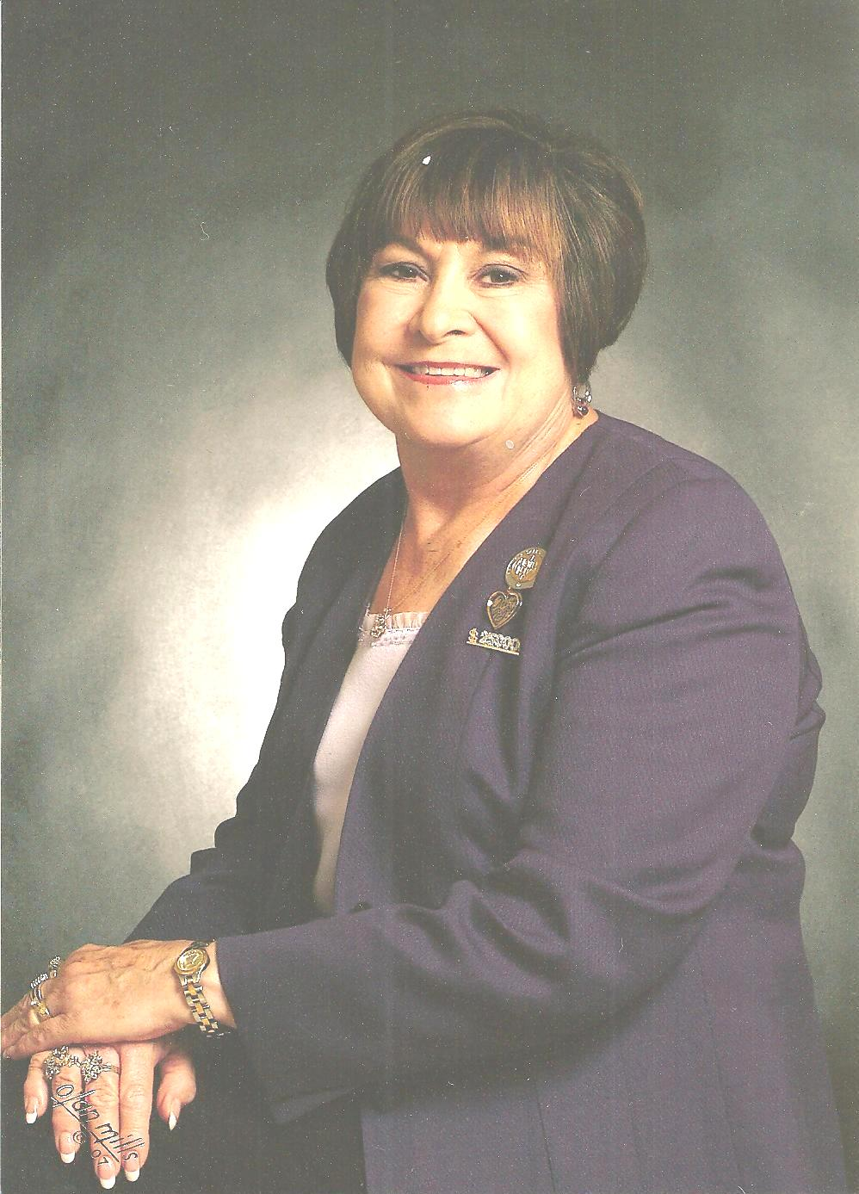

Judi Liles
Sapphire Star
$2,119 wholesale

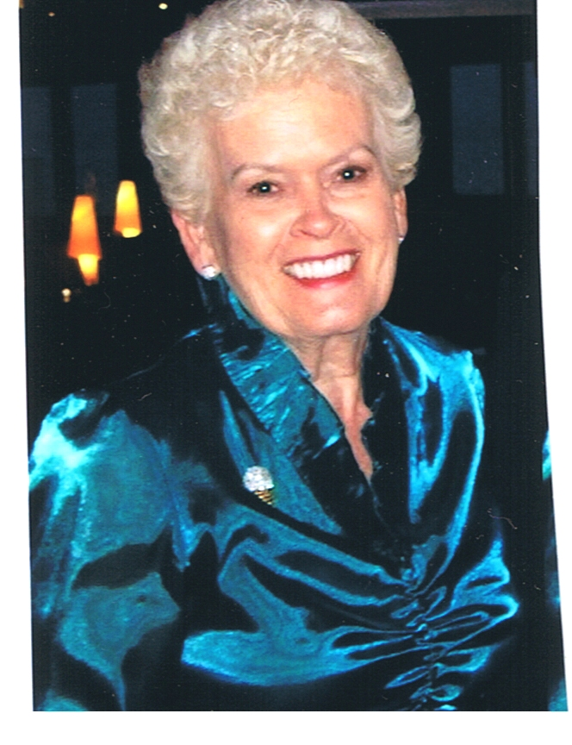

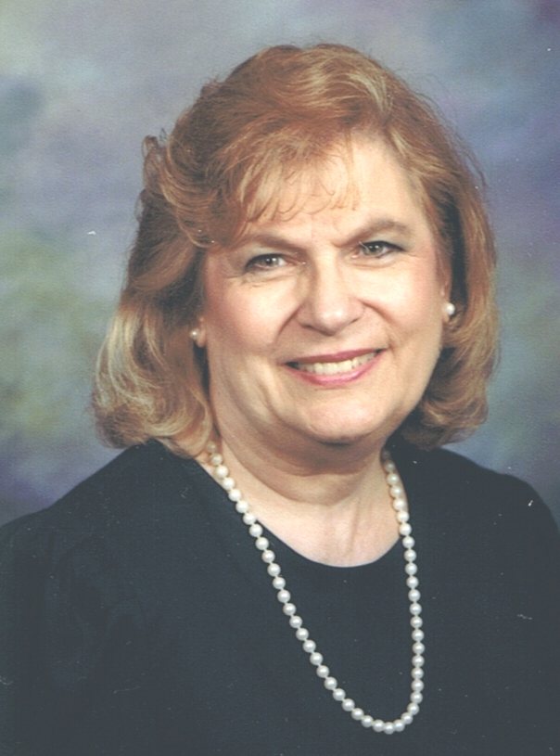
Eileen Hanson
Sapphire Star
$1,882 wholesale

Jackie Hatcher Kay Childers
Sapphire Star Sapphire Star
$1,872 wholesale $1,814 wholesale

Dear Angels,
This month is THE time to recruit! The children are back in school. Moms are getting back into a routine. Holiday ideas are starting to show up in stores, and women are beginning to think about gift ideas. This is also a time that we start feeling the squeeze for extra cash for the Holidays, school supplies, and winter clothes. Mary Kay can be a solution! Wouldn’t you enjoy bringing peace to another woman who is worried about where her children’s gifts will come from this year? If she isn’t sure if Mary Kay is right for her, give her the opportunity of trying it for this Holiday Season. Many companies hire extra help for the Holiday Season. If she begins now, she will have the time to use her skills before the Holidays and make the most of them. It could change her life. Give her that Opportunity. Many thanks to Future Executive Senior Sales Director Natalie Reed for this insight, Andrea.

New for the Seminar 2011 Year! Do at least two of the five, to qualify for Andrea’s Inner Circle each month! Your picture will be in Andrea’s Hall of Fame for that Month in the newsletter on the front page and you will receive a special gift from me. Completing the Elite Inner Circle – all five of the challenges will help you build your business quickly and you will be awarded something extra special! This will certainly make you a “Woman of Excellence”. Fill out this page with names and retail sales and wholesale amounts and return to me at the end of each month to receive your rewards!

Put product on at least 8 people:
1.________ 2._________ 3._________ 4.________ 5.___________ 6.__________ 7.__________

8.________ 9._________ 10.________ 11.________ 12.________ 13.________ 14.________

Team Building: 2 or more interviews or guest who listen to marketing plan:

1.________ 2._________ 3.________ 4.________ 5._________ 6._________ 7._________

One New Team Member: 1. __________

$800 or more in Retail Sales: Total sales amount $_______

$400 or more in Wholesale Orders: Total wholesale amount $_____

I am a Member of Andrea’s Inner circle: ________________________________
(Sign Your Name)
Open House Ideas by Executive Senior Sales Director Natalie Reed - (Thanks Natalie!)
When: Hold your Open House in early November or very early in December (or both) – don’t wait till the middle of December – for one the order form ends on December 15th and most of the Holiday items are sold out by then. A lot of MK consultants hold theirs on the weekend after Thanksgiving (after all it is the biggest shopping day of the year!) If you are busy that weekend – you can hold it the week before Thanksgiving! If you wait – a lot of people will have already bought their holiday items.
Don’t do a marathon Open House – 1-2 days max. I normally do mine in my home on the first Friday and Saturday of November. My hours are 9:30AM till 7:00 PM on Friday and 9:30 AM till 2:00 PM on Saturday. I have tried it from 9am09pm and you spend your time sitting around waiting for people to arrive – the longer the Open House Is – the more waiting you will be doing. If you are new in the business – say less than 50 customers – I would just do it ONE DAY, but keep your items up if you have the room and make private appointments with others that cannot come on your scheduled days. I sell more many times after the scheduled Open House.
Invitations: Send invitation out one to two weeks in advance. I normally send postcards but I also have a flyer that I start putting in the customer’s packages in October. If they will RSVP, I give them a gift determined by the amount they spent that last year. This can only be redeemed at the Open House. I have a basket of past PCP items and after they spend over $50 they get to pick anyone they want. I also include in my invitation that if they cannot come, they can call to set a private appointment.
Call all of your invites a couple of days before to confirm if your numbers are not too big. During DEAD TIME, pick up the phone and start calling to remind them. This really works. If they cannot attend on your dates then set another private appointment with them.
Food should be easy to eat and to make. I put out Tuna salad and bread so they can make small sandwiches. I have hot cider cooking, chips and dips, nuts, crackers and cheese. Holiday cookies and M&M’s all over the tables for them to pick up and eat while they shop. Don’t cook for weeks to get ready – they need to be more interested in your products – not your food – nor your house decorations, but that certainly gets them there once they have attended before. They can come during lunchtime, eat and shop.
Speaking of house decorations – You can get gold or glitter poinsettias to pop around the area you will be in. I use dark green Holiday damask cloths on the tables rather than Christmassy ones. It will seem more elegant; your products will stand out more. Lots of Christmas decorations will make your tables seem too cluttered. Have Holiday CDs playing softly in the background and have a couple of spice candles lit to create the holiday buying mood! This is so important.
Product displays – One trick to highlight your products is to put shoe boxes on other boxes underneath your table cloth – in 2 or 3 places – then place basket on top. You can also make them look like steps and place items on different levels. A totally FLAT display is not nearly as attractive. Remember the eye buys! Don’t go cheap on your bows. 2 pieces of curling ribbon tied in a little bow on the top of a large basket cheapens it. No bow is better than a cheap one. Buy the pull-bows that are quick and easy. Put basket in cello Bags. They will look sharp and clean especialy with a great bow on top. Have some of your MK gift bags ready and tissue or go buy Holiday tote bags and give them with purchase. You can just stick to these bags (the small and large) to do all of your gift bags – except for maybe having a few larger one for things that won’t fit. I normally offer FREE gift bags with purchase.
Open House Ideas (continued)
Group things together – skin care – supplements on one table – Color products on another – Holiday Limited Editions on another – Fragrances & Spa on another and Men’s on another table. If you don’t have extra tables – just group them in sections of your dining room table or around the room. I had the product out of the box and then the extra boxes of products sitting behind – so they could just pick them up and put them in a bag as they shopped. You will also want to have a table of just under $10- $15 – Hand Cream in a mug, body lotion, all colorfully wrapped for easy purchase. These make great Teacher’s gifts, gifts for drop by friends, and people they may have forgotten.
Have one table with a mirror, tray and some samples – I have had several of my customers sit down and try some new colors – or bring their daughter or a friend for a quickie makeover. You might want to place in front of each product s sample of that product especially perfumes and spa sets, easy way for them to smell without spraying up the entire room.
Have a Sales Ticket, Look Book, Business card, a Wish List and list of special together to give to each customer. Have a sign in sheet – ask for their email address and home address just to check your records.
Specials – Make this simple and don’t give away your shirt – as Mary Kay would say! Never discount basic products unless they are on the way out. They are always going to purchase this anyway – there is no need to discount it. Put your biggest discount on items that you may not sell a lot of or items being discontinued. You can do creative specials. Buy 2 and get one free or buy one and get one at half price. You could even do the balloon specials – insert the amount of discount on a piece of paper – slip it in a balloon and them pop a balloon to see what kind of discount they get. Have plenty of 10%, 15%, a few 20% & 25% and then maybe 1 or 2 at 30% and 40%. This makes it fun!
If you are low on inventory, you will have to take orders and then deliver later. Let them know the day you will be placing your order and tell them it will be a week from then that you will deliver. I would collect all of your money up front. That way you have the cash to do your order. The less inventory you have, the sooner you will want to schedule your Open house. During the Holiday season – UPS is slower and of course the “good stuff” sells out quickly. Don’t let your people be disappointed. If you make baskets, let them know if they are one of a kind.
When you do Holiday coffees at either your house or the house of a hostess, you would really do all of the above on a smaller scale. If you can get the hostess to bring her guests to your house, you can always do a better display and have more products available. If this will not work then select what to bring according to the numbers attending and the people and their needs.
Finally, look at your displays. Look at your food and your specials. Would it impress you? BRAND NEW? Buddy up with a sister consultant. Do one at her house and one at yours on a different month! Invite your new recruits to come and help you that week. You can train her when no one is there. Last piece of advice. CALL CALL CALL. Do not depend on your invitations alone. Start telling everyone NOW!

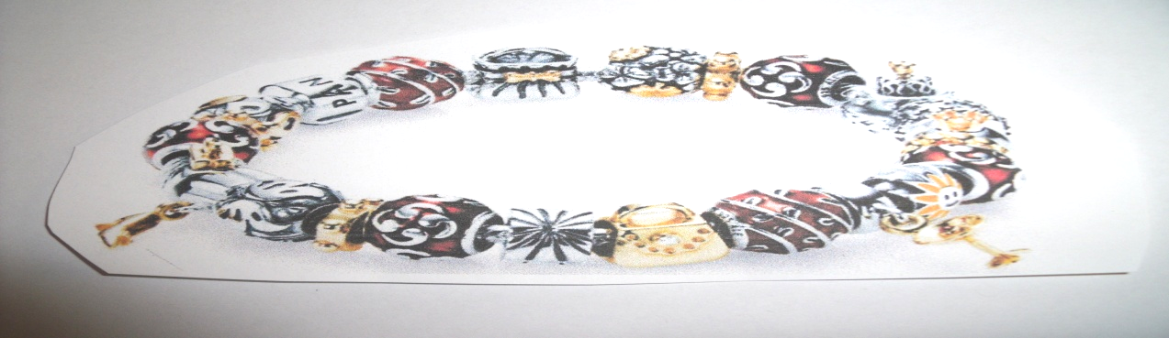
“Pandora” Look alike Bracelet & Beads
(Inspired by Pandora Bracelets. Bead selection will vary from above pictured example.)
1 Bead 2 Beads 3 Beads 4 Beads 5 Beads
$250 Whls. $400 Whls. $600 Whls. $800 Whls. $1,000 Whls.
ALSO
Receive a bead for each active team member you bring in. (Active = $200 whls. order in the same month as her agreement went in.)

Have you seen these EXPENSIVE but beautiful bracelets? Would you LOVE to have your own? Well, now you can! Starting in the month of October, you can win your bracelet and begin to fill it up with these fabulous beads throughout this Seminar year. WOW! Build – A – Bracelet! Build – A – Business!

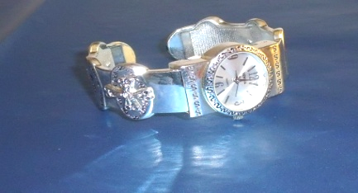
Keep a record of your Shows or Parties you Hold this Seminar Year. On holding your 10th Show, you will receive this beautiful Silver Inspirational Bracelet Watch. Just do this in this Seminar Year. Let’s all help Ryan Rogers, Mary Kay’s Grandson, reach our company Goal of 5 Billion in Sales by 2013. All you have to do is just call me and say “I DID IT!”

$1,000 Wholesale – Austrian Jet Crystals – Jackie Hatcher and Ruth Hise
$800 Wholesale – Black Wallet Clutch – Judi Liles
$600 Wholesale – Footprints Pen – Beryl Greenawalt
$450 Wholesale – Patricia Colbert, Phyllis Jones, and Gloria McCutcheon
$250 Wholesale – Michelle Allen, Delma Aranda, Christine Castioni, Kay Childers, Donna Cox, Becky Farris, Beverly Guthrie, Barbara Kelly, and Dolores Montoya

Happy Birthday
October Day
Nancy C. Little 11
Martha J. Lange 21
Carla A. Villyard 21

Mary Kay Anniversary
October Years
Patricia R. Hopkins 35
Candace D. Entingh 26
Doreta Higginbotham 19
Ruby F. Hulett 18
Julie K. White 15
Angela M. Sabourin 7
Nelly Kwok 5
Crystal D. Watson 4
Jennifer A. Gustin 1

Your Guide to What’s Inside
October Hall of Fame (page1)
August Scoreboard (page 2)
Recruiter & their Teams (page 3)
Gett Referrals to Book Classes-p4
Star Consultants/Dear Angels (p5)
Andrea’s Inner Circle (page 6)
Open House (pages 7-8)

October Promo/Prizes Won (p. 9)
Birthdays/Anniversaries (page 10)

“People will forget those things that you do.
People will forget what you say.
But people will never forget how you made them feel.”

Andrea Pace, Future Executive Senior Sales Director
4206 Southfield Road
Ellicott City, Maryland 21042-5906
(410) 465-4442 or 1-800-863-2463
Fax No. (410) 313-9294; Cell Phone: (443) 980-7353
E-Mail Address – andrea@andreapace.com
Web Site for Andrea’s Consultants:
http://www.andreapace.com
Customer Website:
http://www.marykay.com/andreapace

Matthew 5:16 “. . . . you should be a light for other people. Live so that they will see the good things you do and will praise your Father in heaven.”

