Andrea's Pace-Setting Angels

$300,00 Circle of Achievement Unit
Chevy Equinox Unit

December 2010 Newsletter (October 2010 News)
Andrea Pace Unit 0154 -- 4206 Southfield Road, Ellicott City, Maryland 21042
Phone: (410) 465-4442 or 1-800-863-2463; FAX: (410) 313-9294;
Cell Phone: (443) 980-7353; Email: andrea@andreapace.com
Web site for Andrea’s Consultants: http://www.andreapace.com (Password: 0154)
Customer Website: http://www.marykay.com/andreapace

Welcome New Consultants
Darchelle Colbert (Jacksonville, FL) – Sponsored by Patricia Colbert
Judith Weiner (Dover, DE) – Sponsored by Andrea Pace

Welcome Back -- Reinstated Consultants
Jody Colwell (Wortham, TX) Doreta Higginbotham (Abilene, TX)
Linda King (Tucson, AZ) Cynthia Ostermann (Crestview, FL)
Justine Schaeffer (Ellicott City, MD) Ellen Wallace (Lubbock, TX)

Consultants Participating in Preferred Customer Program
Michelle Allen Christy Fagan Donna Canada Kay Childers
Patricia Colbert Beryl Greenawalt Bee Hamlin Eileen Hanson
Margot Howard Phyllis Jones Margie Kitten Judi Liles
Mary McNamee Jana Morgan Andrea Pace Claudia Tufano
B.J. Watson Susan Wesner


Smart women let Mary Kay Corporate help them keep in touch with their best customers by participating in PCP, the Preferred Customer Program.

PCP helps a Mary Kay Consultant avoid the paper overload shown here.

If you do not participate in PCP, be like the smart women named above and start participating at the next opportunity.

October 2010 Scoreboard

Consultants Ordering In October 2010 Queen Phyllis Jones -- $872

Delma Aranda
Helen Bearden
Christa Brack
Donna Canada
LaJoyce Cannon
Christine Castioni
Kay Childers
Ann Cobb
Patricia Colbert
Jody Colwell
Candace Entingh
Becky Farris
LaRon Fulbright
Brenda Green
Beryl Greenawalt
Bee Hamlin
Sandra Hauer
Doreta Higginbotham
Ruth Hise
Phyllis Jones
Linda King
Margie Kitten
Lynn Leonard
Judi Liles
Jana Morgan
Nancy Norris
Cynthia Ostermann
Andrea Pace
Linda Richardson
Sue Robertson
Nancy Sweet
Claudia Tufano
B.J. Watson
Mary Welter
Susan Wesner
Helen Westlund
Pamela White

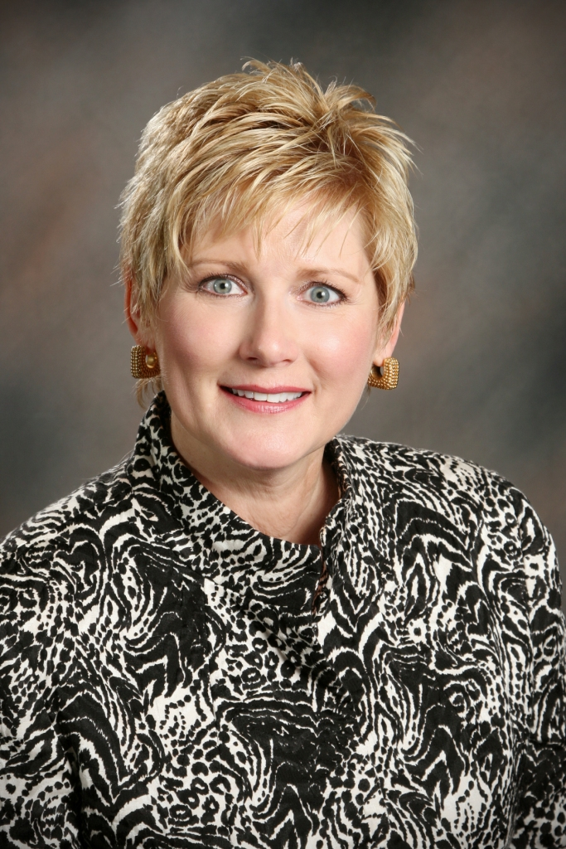

Mary Welter -- $739

Court of Sharing (to 10/31/2010)

Beryl Greenawalt – 1
Judi Liles -- 1

Year to Date Retail Production thru 9/30/2010
1 Kay Childers $7,674.00
2 Judi Liles $6,110.50
3 Phyllis A. Jones $5,577.00
4 Ruth H. Hise $4,538.00
5 Jackie Hatcher $4,046.50
6 Eileen Hanson $3,964.00
7 Donna Canada $3,757.50
8 Dolores M. Montoya $3,408.00
9 Gloria K. McCutcheon $2,954.50
10 Christine T Castioni $2,849.00
11 Nancy G. Grissom $2,705.50
12 Patricia R. Colbert $2,574.50
13 Mary L. Welter $2,254.00
14 Michelle E. Allen $2,230.00
15 Beryl A. Greenawalt $2,174.50
16 LaRon Fulbright $1,963.50
17 Candace D. Entingh $1,704.00
18 Jana R. Morgan $1,678.50
19 Donna G. Cox $1,533.50
20 Bee A. Hamlin $1,459.50

Andrea Pace $8,826.00
Consultants with
September Recruiter Commissions

9% Recruiter Commission Level
Andrea Pace
Judi Liles
Beryl A. Greenawalt

4% Recruiter Commission Level
Ruby F. Hulett
Candace D. Entingh
Jackie Hatcher
Bonnie N. Montgomery
Helen Bearden
Phyllis A. Jones
Donna Canada
Kay Childers
Cheri Akers

Total Unit Retail Production
October 2010 -- $20,798
Seminar Year -- $125,618

Recruiters and their Teams (as of October 31, 2010)

Future Sales Director
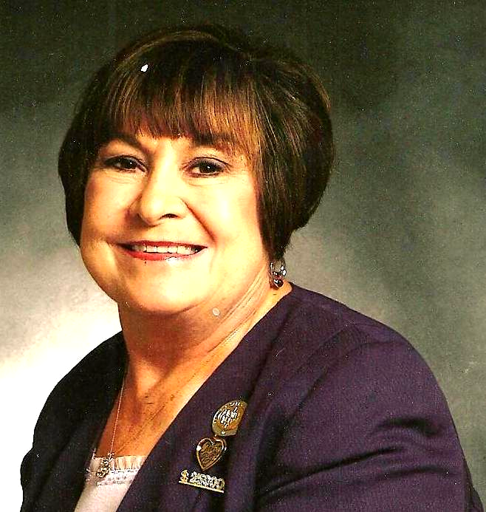
Recruiter: Judi Liles
Cheri Akers
Helen Bearden
LaJoyce M. Cannon
Jody O. Colwell
Brenda Green
Jo L. Henderson
Barbara Kelly
Martha J. Lange
Bobbie L. Merritt
Carol F. Sanders
B.J. Watson
Melba J. Williams
* Brandy M. Blount
* Iris Cummins
* Carla A. Villyard

Team Leader 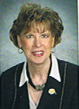
Recruiter: Beryl A. Greenawalt
Lilian Alade
Sharon L. Dixon
Bee A. Hamlin
Nancy L. Norris
Clola M. Robinson
* Angela M. Sabourin

Star Team Builders

Recruiter: Jackie Hatcher
Donna G. Cox
Joyce Johnson
Susan C. Wesner
Helen Westlund
* Yvette A. Birch
* Sandra L. Schillizzi


Recruiter: Mary L. Welter
Taffee Anhder
Magdalena T Arguello
Gabriele I. Trujillo

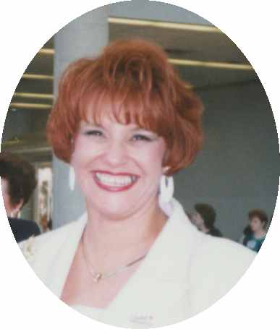
Recruiter: Christine T. Castion
Eileen Hanson
Dolores M. Montoya
Cruz P. Torres
* Lisa Heenan

- = inactive Consultant
Senior Consultants
Recruiter: Bonnie Montgomery
Doreta Higginbotham
* Nancy G. Grissom
* Debra D. Southerland

Recruiter: Candace D. Entingh
Tena K. McElvain
Mary L. Welter

Recruiter: Cheri Akers
Pamela White
* Karen R. Meno

Recruiter: Donna Canada
Cody Hanagan
Linda S. Richardson
* Sherri L. Allen
* Donna K. Gray
* Teresa G. Rubio

Recruiter: Helen Bearden
Ruth H. Hise
* Kaye Richardson

Recruiter: Kay Childers
Linda King

Recruiter: Lynda I. Boland
Beverly L. Guthrie

Recruiter: Margot Howard
Bonnie S. Morrison
Justine Schaeffer

Recruiter: Phyllis A. Jones
Margie J. Kitten
Ellen H. Wallace
* Christy Fagan

Recruiter: Ruby F. Hulett
Phyllis A. Jones

Recruiter: Sharon A. Edwards
Bonnie L. Hobson
* Julie K. White

Star Consultant Contest Status
For Contest Ending December 15, 2010 (as of November 22, 2010)

*************** Needed for Star ***************
Consultant In for Star Sapphire Ruby Diamond Emerald Pearl
Andrea Pace | $2,431.25 | ***** | STAR | $568.75 | $1,168.75 | $2,368.75
Phyllis Jones | $2,416.50 | ***** | STAR | $583.50 | $1,183.50 | $2,383.50
Dolores Montoya | $971.00 | $829.00 | $1,429.00 | $2,029.00 | $2,629.00 | $3,829.00
Judi Liles | $938.25 | $861.75 | $1,461.75 | $2,061.75 | $2,661.75 | $3,861.75
Mary Welter | $776.00 | $1,024.00 | $1,624.00 | $2,224.00 | $2,824.00 | $4,024.00
Christine Castioni | $732.00 | $1,068.00 | $1,668.00 | $2,268.00 | $2,868.00 | $4,068.00
Patricia Colbert | $715.25 | $1,084.75 | $1,684.75 | $2,284.75 | $2,884.75 | $4,084.75
Donna Canada | $695.50 | $1,104.50 | $1,704.50 | $2,304.50 | $2,904.50 | $4,104.50
Laron Fulbright | $651.75 | $1,148.25 | $1,748.25 | $2,348.25 | $2,948.25 | $4,148.25
Candace Entingh | $645.00 | $1,155.00 | $1,755.00 | $2,355.00 | $2,955.00 | $4,155.00
Lynn Leonard | $486.00 | $1,314.00 | $1,914.00 | $2,514.00 | $3,114.00 | $4,314.00
Sue Robertson | $452.25 | $1,347.75 | $1,947.75 | $2,547.75 | $3,147.75 | $4,347.75
Becky Farris | $417.25 | $1,382.75 | $1,982.75 | $2,582.75 | $3,182.75 | $4,382.75
Doreta Higginbotham | $408.75 | $1,391.25 | $1,991.25 | $2,591.25 | $3,191.25 | $4,391.25
Ruth Hise | $403.50 | $1,396.50 | $1,996.50 | $2,596.50 | $3,196.50 | $4,396.50
Ann Cobb | $400.50 | $1,399.50 | $1,999.50 | $2,599.50 | $3,199.50 | $4,399.50
Teresa Rubio | $400.25 | $1,399.75 | $1,999.75 | $2,599.75 | $3,199.75 | $4,399.75

Dear Angels,
This is such an exciting time of the year for all of us. I have been making gifts all year long for my loved ones. This year I have made a couple of Rag Quilts, and a bunch of hot stamped embroidery kitchen towels. That relaxes me in the evening from my busy day. Dale puts a fire in the fireplace and I am all cozy and warm and just work like crazy. I also love to do small cross stitch table cloths. One of my neighbors put us up when we were without power for 6 days last February when we had 2 huge snow storms. So, I am making her a table cloth. Someone once asked why I didn’t sell my work, but there is no amount of money that you could pay me for the hours I put into a project. Besides, that would take away from me the joy of making something special for someone special. I also love to give my Mary Kay as gifts. I have gotten a lot of customers that way. When I see that someone needs something in my product line I give it to her, and before you know it, she begins ordering product from me. They don’t all buy, but most do.
The more you give in the lives of others, comes back into your own, pressed down, shaken together will it be given back to you. That’s why I love this season in remembering what Jesus did for all of us. In my small way, I do what I can to make a new friend feel good about themselves.
Oh I am so excited, I have to tell you about my Open House. I had non-stop customers all day long and 7 deep waiting to get their orders filled. I had cooked all day on Friday, so I had them entertained with food, Hot Wessel, visiting with one another, and writing down on order sheets what they wanted. My sales were $3,350. I was thrilled. Dale helped me out by refilling all the food trays. God is good. I am grateful and yes, I was one tired Consultant.
Inside is great information on fragrances. Be sure and keep this for your files.
Also do your best to make sure your orders are $250 plus so you can begin earning your
Pandora Look-A-Like Beads. I have the October Beads in and they will soon be in the mail to you.
In January I will be attending Leadership Conference in Houston, Texas. I get to room with Director Helen Fellows. This will be a great education event for the both of us. Plus we always have so much fun together. Have a Merry Christmas and a Wonderful New year, Andrea
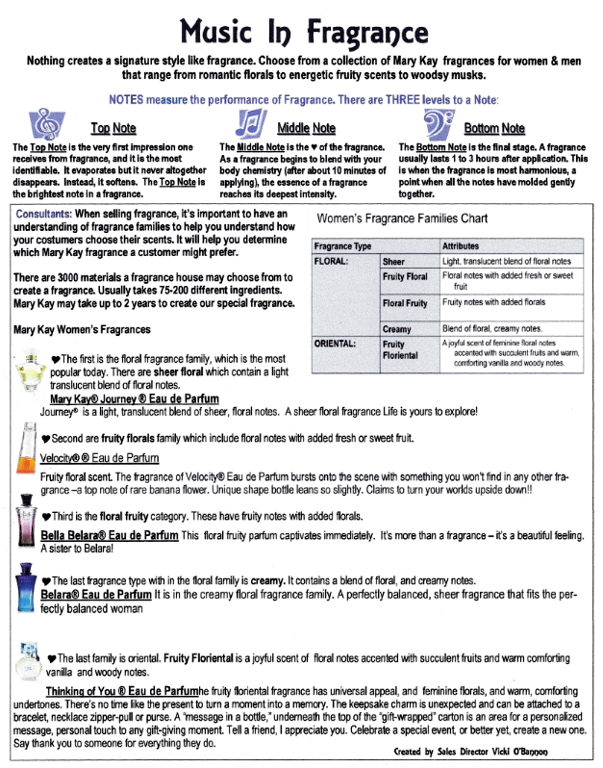
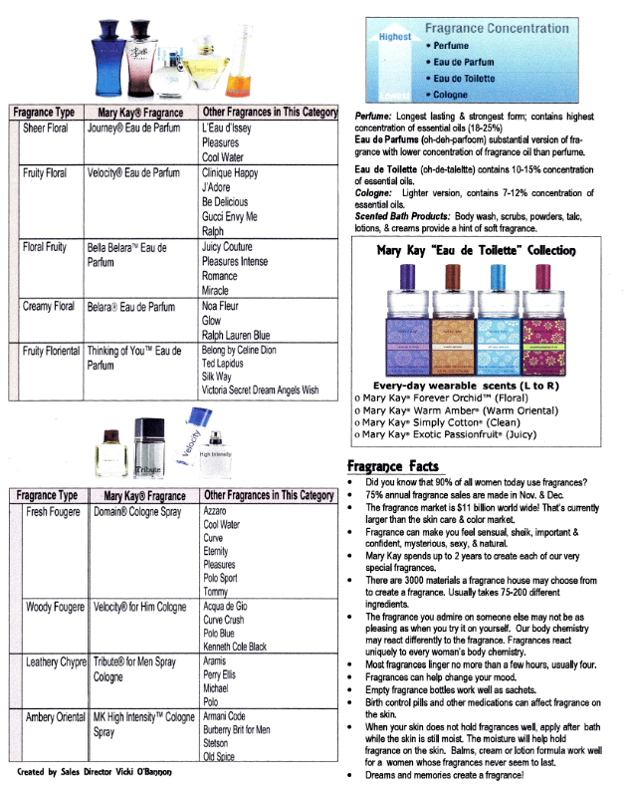
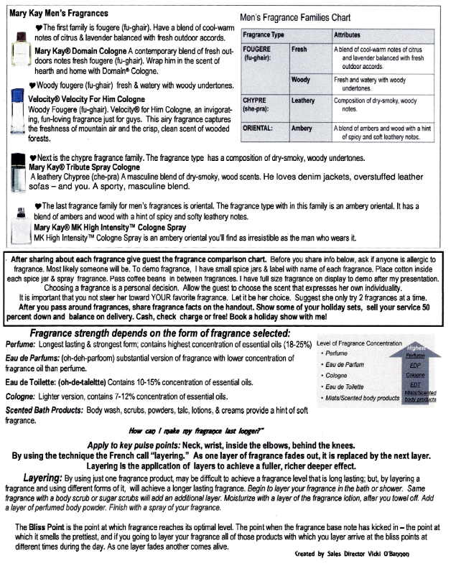

Today I am going to highlight a type of Character to have…… Perseverance

“We must not become tired of doing good. We will receive our harvest of eternal life at the right time if we do not give up”. Galatians 6:9
Another version states it this way:” Let us not become weary in doing good, for at the proper time we will reap a harvest if we do not give up”. Galatians 6:9
“My brothers and sisters, when you have many kinds of troubles, you should be full if joy, because you know that these troubles test your faith, and this will give you patience”. James 1:2-3

God Blesses Endurance
Are you close to quitting? Please don’t do it. Are you discouraged as a parent? Hang in there. Are you weary with doing good? Do just a little more. Are you pessimistic about your job? Roll up your sleeves and go at it again. No communication in your marriage? Give it one more shot. Can’t resist temptation? Accept God’s forgiveness and go one more round. Is your day framed with sorrow and disappointment? Are your tomorrows turning into nerves? Is hope a forgotten word?

Remember, a finisher is not one with no wounds or weariness. Quite to the contrary, He, like the boxer, is scarred and bloody.

The Land of Promise, says Jesus, awaits those who endure. It is not just for those who make the victory laps and drink champagne. No way. The Land of Promise is for those who simply remain until the end.

Like me I am sure that you’ve been through seasons when one crisis seems to roll in behind another, when you are faced with losses beyond what your heart can bear. I am not glad when these troubles happen. I do not rejoice over loss. However, when my heart is sore, I am aware that it is still beating…I am still alive and life is strangely abundant. Had God not taught me His word…and I am glad that He still is teaching me, I think that I might of quit. If you, too, tend to fear having your heart broken, ask God to redirect your energies toward faithfulness instead. Change your focus OFF of yourself and onto another person.

My Prayer for you is for you to gain strength through the truth of the word and that with that strength, you persevere through your trials. There is Peace at “the end of the tunnel”

“Let the beauty of the LORD our God be upon us, and establish the work of our hands for us; yes, establish the work of our hands” Psalm 90:17

Love and Blessings, Sales Director Trish Meier


December Prize Promotion
“Pandora” Look-a-like Bracelet & Beads
(Inspired by Pandora Bracelets. Bead selection will vary from above pictured example.)
1 Bead 2 Beads 3 Beads 4 Beads 5 Beads
$250 Whls. $400 Whls. $600 Whls. $800 Whls. $1,000 Whls.
ALSO
Receive a bead for each active team member you bring in. (Active = $200 whls. order in the same month as her agreement went in.
Receive 3 Beads for Completing Star Consultant by December 15th, 2010.
Have you seen these EXPENSIVE but beautiful bracelets? Would you LOVE to have your own? Well, now you can! Starting in the month of October, you can win your bracelet and begin to fill it up with these fabulous beads throughout this Seminar year. WOW! Build – A – Bracelet! Build – A – Business!

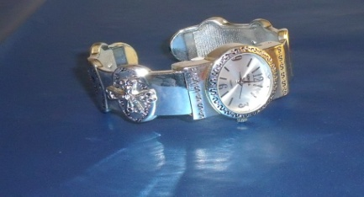
Keep a record of your Shows or Parties you Hold this Seminar Year. On holding your 10th Show, you will receive this beautiful Silver Inspirational Bracelet Watch. Just do this in this Seminar Year. Let’s all help Ryan Rogers, Mary Kay’s Grandson, reach our company Goal of 5 Billion in Sales by 2013. All you have to do is just call me and say “I DID IT!”

$800 Wholesale –4 Beads with Bracelet - Phyllis Jones
$600 Wholesale –3 Beads with Bracelet– Mary Welter
$400 Wholesale – 2 Beads with Bracelet – Christine Castioni, Ann Cobb, LaRon Fulbright, Doreta Higginbotham, Ruth Hise, and Sue Robertson
$250 Wholesale – 1 Bead with Bracelet – Christa Brack, Donna Canada, LaJoyce Cannon, Kay Childers, Candace Entingh, Margie Kitten, Judi Liles, and Claudia Tufano

Happy Birthday
December Day
Judi Liles 1
Sherri L. Allen 2
B.J. Watson 3
Candace D. Entingh 11
Sharon L. Dixon 14
Carol F. Sanders 18
Donna K. Gray 20
Marilee Mandernach 26
Cynthia J. Ostermann 29

Mary Kay Anniversary
December Years
Delma C. Aranda 31
Nina G. Mack 28
Helen Westlund 28
Nancy G. Grissom 20
Marilee Mandernach 20
Karen R. Meno 13
Susan C. Wesner 11
Mary C. McNamee 8
Nancy L. Norris 7

Your Guide to What’s Inside
PCP (page1)
OctoberScoreboard (page 2)
Recruiter & their Teams (page 3)
Star Status/Dear Angels (page 4)
Fragrance (pages 5-7)
Inspiration (page 8)

Dece. Promo/Prizes Won (p. 9)
Birthdays/Anniversaries (page 10)

Serious Cash Essentials…for great profits this holiday Season
Holiday Skin Care Classes – Holiday Coffees – Holiday On the Go Appointments
12 Days of Christmas – Holiday Open Houses
Employee Gifts, a special service for doctors, dentists, and other professionals
Wish Lists – give them to customers and call their “Santa” and giv de them list
Silent Holiday Hostesses – offices, club s and schools – Private Holiday Makeover
Pillow Gifts – a special gift to give Christmas nightg on her pillow
Emergency Giftgs – for hostesses, or friend who brings you unexpected gift
Gifts for the office – the boss, secfretary, fellow employees, secfret Santas
Personal Gift Giving – buy your gifts for 50% off!

Andrea Pace, Future Executive Senior Sales Director
4206 Southfield Road
Ellicott City, Maryland 21042-5906
(410) 465-4442 or 1-800-863-2463
Fax No. (410) 313-9294; Cell Phone: (443) 980-7353
E-Mail Address – andrea@andreapace.com
Web Site for Andrea’s Consultants:
http://www.andreapace.com
Customer Website:
http://www.marykay.com/andreapace

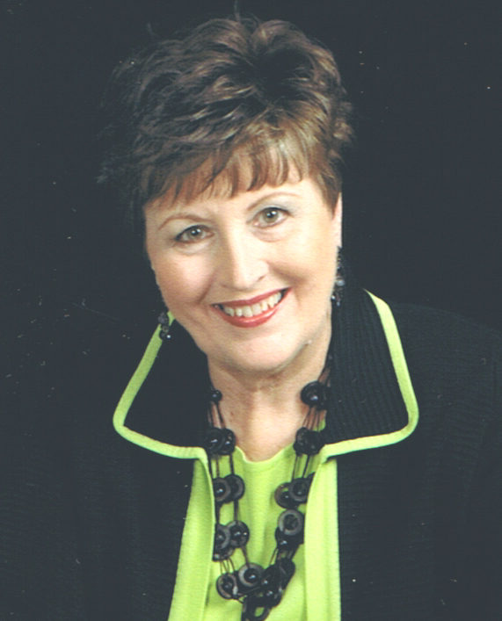

“I tell you, God will help his people quickly. But when the Son of Man comes again, will he find those on earth who believe in him?” Luke 18:8

