Andrea's Pace-Setting Angels

$300,00 Circle of Achievement Unit
Chevy Equinox Unit

August 2010 Newsletter (June 2010 News)
Andrea Pace Unit 0154 -- 4206 Southfield Road, Ellicott City, Maryland 21042
Phone: (410) 465-4442 or 1-800-863-2463; FAX: (410) 313-9294;
Cell Phone: (443) 980-7353; Email: andrea@andreapace.com
Web site for Andrea’s Consultants: http://www.andreapace.com (Password: 0154)
Customer Website: http://www.marykay.com/andreapace

Welcome New Consultants
Kimberly Ann Bauer (Rathdrum, ID) – sponsored by Judi Liles

Welcome Back -- Reinstated Consultants
Billie Jean Beckham (Jal, NM) Carla Villyard (Katy, TX)

Hall of Fame for August 2010

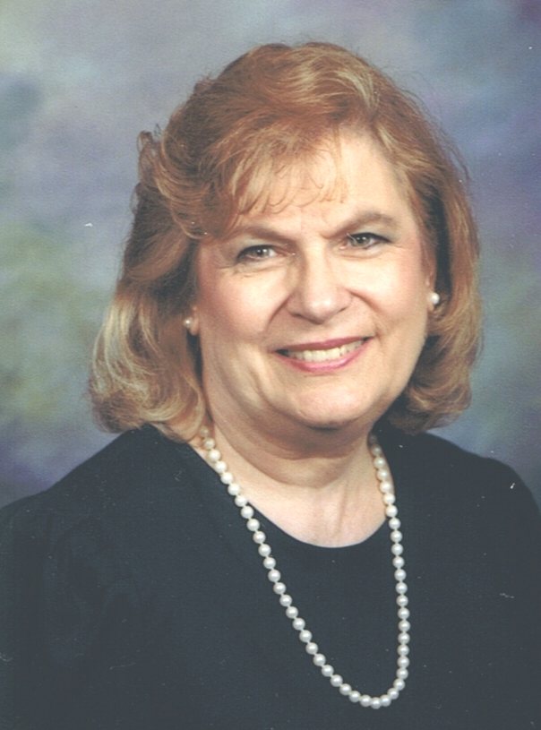
Kay Childers Andrea Pace
$1,604 wholesale production Registered for Seminar
Registered for Seminar

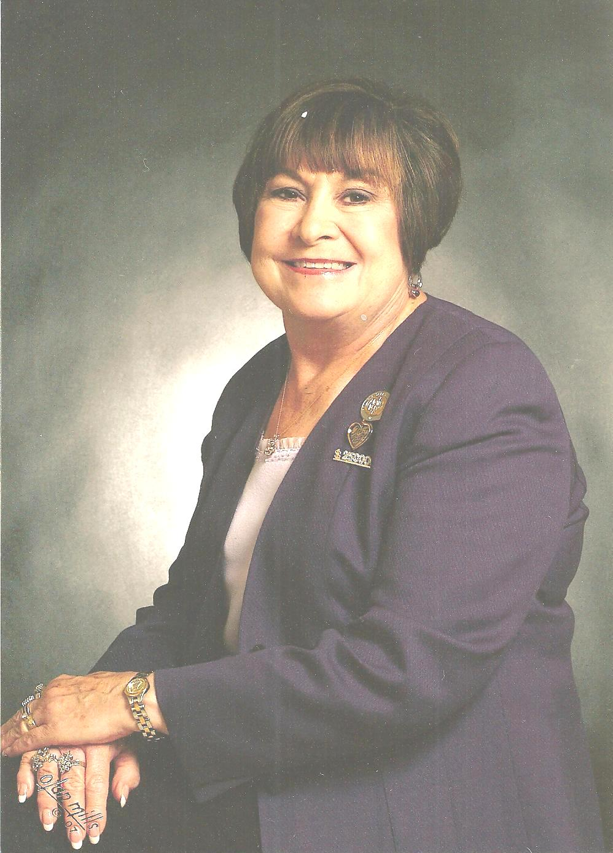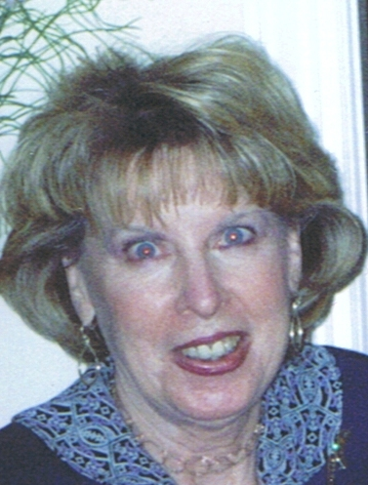
Judi Liles Beryl Greenawalt
$1,278 wholesale production Registered for Seminar
June 2010 Scoreboard

Consultants Ordering In June 2010 Queen Kay Childers -- $1,604

Michelle Allen
Helen Bearden
Billie Beckham
Donna Canada
Pat Carrasco
Christine Castioni
Kay Childers
Patricia Colbert
Sharon Edwards
Joyce Foster
Donna Gray
Bee Hamlin
Cody Hanagan
Ruth Hise
Patricia Holt
Patricia Hopkins
Margot Howard
Ruby Hulett
Phyllis Jones
Margie Kitten
Lynn Leonard
Judi Liles
Gloria McCutcheon
Mary McNamee
Karen Meno
Dolores Montoya
Nancy Norris
Andrea Pace
Linda Richardson
Teresa Rubio
Debra Southerland
Nancy Sweet
Cruz Torres
Geneva Trujillo
Claudia Tufano
Carla Villyard
Joker Ward
B.J. Watson
Mary Welter
Susan Wesner
Julie White

Judi Liles -- $1,278
Donna Canada -- $709
Dolores Montoya -- $673
Gloria McCutcheon -- $624

Andrea Pace -- $992

Court of Sharing (Year to Date)
Eileen Hanson – 1 qualified Consultant
Judi Liles – 4
Donna Canada – 2
Margot Howard – 2
Christine Castioni – 1
Kay Childers -- 1
Sharon Edwards – 1
Beryl Greenawalt - 1
Phyllis Jones -- 1
Lynn Leonard – 1
Bonnie Montgomery -- 1
Qualified = $600 wholesale order

Year to Date Retail Production (thru June 30th)
1 Kay Childers $20,463.50
2 Judi Liles $16,497.00
3 Phyllis A. Jones $15,827.50
4 Ruth H. Hise $9,692.50
5 Dolores M. Montoya $8,077.00
6 Gloria K. McCutcheon $7,635.00
7 Donna Canada $6,745.00
8 Christine T Castioni $6,708.00
9 Jackie Hatcher $6,310.00
10 Donna G. Cox $5,913.50
11 Eileen Hanson $5,547.00
12 Teresa G. Rubio $4,689.50
13 Mary L. Welter $4,617.00
14 Patricia R. Colbert $4,611.00
15 Susan C. Wesner $4,096.50
16 Joker Ward $3,859.50
17 Michelle E. Allen $3,627.50
18 Nancy L. Norris $3,603.50
19 Jana R. Morgan $3,503.00
20 Candace D. Entingh $3,461.50

Andrea Pace $28,916.50
Consultants with
June Recruiter Commissions
13% Recruiter Commission Level
Andrea Pace
9% Recruiter Commission Level
Judi Liles
Jackie Hatcher
Beryl A. Greenawalt
4% Recruiter Commission Level
Donna Canada
Christine T Castioni
Helen Bearden
Sharon A. Edwards
Delma C. Aranda
Bonnie N. Montgomery
Ruby F. Hulett
Cheri Akers
Phyllis A. Jones
Candace D. Entingh

Total Unit Retail Production
June 2010 -- $30,753
Seminar Year -- $308,722 (Unit Club !)

Recruiters and their Teams (as of June 30, 2010)

Future Sales Director
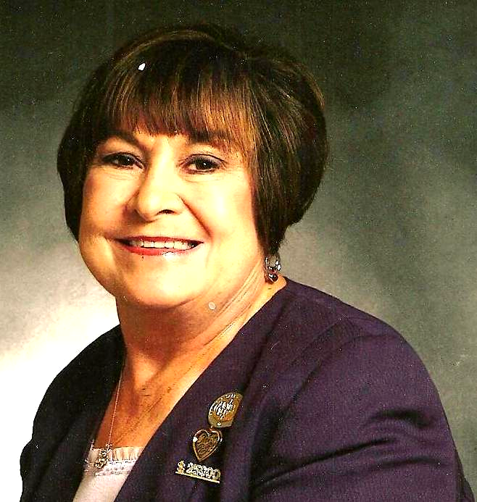
Recruiter: Judi Liles
Cheri Akers
Helen Bearden
Brandy M. Blount
LaJoyce M. Cannon
Patricia A. Holt
Virginia L. Jones
Barbara Kelly
Marilee Mandernach
Bobbie L. Merritt
Carol F. Sanders
Carla A. Villyard
B.J. Watson
Melba J. Williams
MaryAnn Youngblood
* Kimberly A. Bauer
* Jody O. Colwell
* Jo L. Henderson
* Martha J. Lange
* Robbie F. Litzman

Team Leaders
Recruiter: Beryl A. Greenawalt
Sharon L. Dixon
Sandra Gutierrez
Bee A. Hamlin
Nancy L. Norris
Crystal D. Watson
* Betty M. Everett
* Clola M. Robinson

- = inactive Consultant

Team Leaders

Recruiter: Jackie Hatcher
Donna G. Cox
Joyce Johnson
Sandra L. Schillizzi
Susan C. Wesner
Helen Westlund
* Sharon L. Slaughter

Star Team Builders

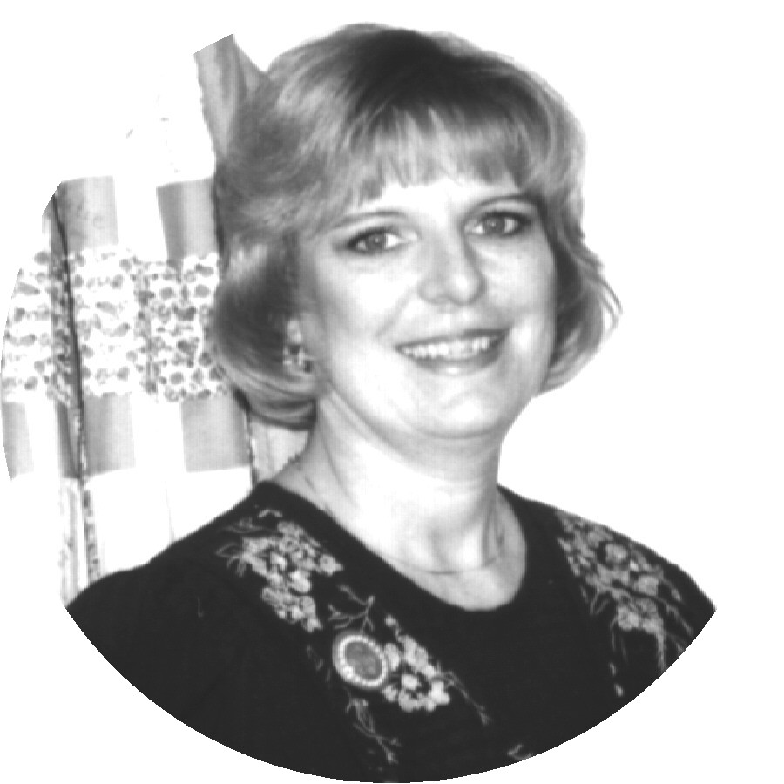
Recruiter: Donna Canada
Donna K. Gray
Cody Hanagan
Linda S. Richardson
Teresa G. Rubio
* C R. Akins

Senior Consultants
Recruiter: Bonnie Montgomery
Jana D. Laubscher
Debra D. Southerland
* Doreta Higginbotham

Recruiter: Candace D. Entingh
Tena K. McElvain
Mary L. Welter

Recruiter: Cheri Akers
Karen R. Meno

Recruiter: Christine T. Castion
Dolores M. Montoya
Cruz P. Torres
* Carol A. Estebo
* Sandy Flores
* Eileen Hanson

Recruiter: Delma C. Aranda
Pat Carrasco

Recruiter: Eileen Hanson
Geneva D. Trujillo

Recruiter: Helen Bearden
Ruth H. Hise
Kaye Richardson

Recruiter: Lynda I. Boland
Beverly L. Guthrie

Recruiter: Margot Howard
Bonnie S. Morrison

Recruiter: Mary L. Welter
Magdalena T Arguello
Gabriele I. Trujillo
* Taffee Anhder

Recruiter: Phyllis A. Jones
Christy Fagan
Margie J. Kitten
* Ellen H. Wallace

Recruiter: Ruby F. Hulett
Phyllis A. Jones

Recruiter: Sharon A. Edwards
Julie K. White
* Bonnie L. Hobson

3rd Quarter Star Consultant Promotion
Promotion starting 6/16/10 – ending 9/15/10 (as of July 22, 2010)
************** Needed for Star **************
Consultant For Star Sapphire Ruby Diamond Emerald Pearl
Nancy Grissom | $1,310.75 | $489.25 | $1,089.25 | $1,689.25 | $2,289.25 | $3,489.25
Eileen Hanson | $1,279.25 | $520.75 | $1,120.75 | $1,720.75 | $2,320.75 | $3,520.75
Donna Canada | $705.00 | $1,095.00 | $1,695.00 | $2,295.00 | $2,895.00 | $4,095.00
Judi Liles | $671.25 | $1,128.75 | $1,728.75 | $2,328.75 | $2,928.75 | $4,128.75
Gloria Mccutcheon | $624.00 | $1,176.00 | $1,776.00 | $2,376.00 | $2,976.00 | $4,176.00
Teresa Rubio | $600.50 | $1,199.50 | $1,799.50 | $2,399.50 | $2,999.50 | $4,199.50
Phyllis Jones | $495.50 | $1,304.50 | $1,904.50 | $2,504.50 | $3,104.50 | $4,304.50
Julie White | $450.00 | $1,350.00 | $1,950.00 | $2,550.00 | $3,150.00 | $4,350.00
Bee Hamlin | $428.00 | $1,372.00 | $1,972.00 | $2,572.00 | $3,172.00 | $4,372.00
Jana Morgan | $404.75 | $1,395.25 | $1,995.25 | $2,595.25 | $3,195.25 | $4,395.25
Donna Cox | $401.00 | $1,399.00 | $1,999.00 | $2,599.00 | $3,199.00 | $4,399.00

Dear Angels,
Happy New MK Year! I love that we get 2 new year celebrations in Mary Kay. It is time to celebrate this past Seminar year and it is time to focus on our new goals and dreams for Seminar 2011. My heart is so full and I am humbled by your unit loyalty and faithfulness. We ran the race for this past Seminar with dignity, pride and a spirit of fun. It brought out the very best in each of us and it is an incredible springboard to what we can do in this next Seminar year.
Our Unit Goal is to achieve the $350,000 Unit Club with 6 Star Consultants each quarter. I want to honor all of you who have achieved Star Consultant each of the 4 quarters. Please read the article on how to be a 4 Quarter Star Consultant in this newsletter. My treat to you is a 4 Quarter Star Dinner at the Houston’s Restaurant on Day 00 at Seminar 2011. Start planning and saving knowing YOU will be there as a WINNING SUPER STAR CONSULTANT.
What I love about this business is that it is all mathematical and not magical! If you do the work, the results will come. Make new friends…Earn a MK car…Impact the lives of others…change your financial position. Women are purchasing cosmetics. You just need to make sure that everyone knows about the wonderful MK products and that YOU are a MK consultant. We have great products at a great price and the customer gets her own personal beauty consultant – YOU!
We leave for Seminar 7/28 and will be back in the office 8/6/10. So our pictures of the Mary Kay Seminar will be in the September, 2010 Newsletter. I am so excited that Beryl Greenawalt will be joining Dale, Kay Childers and me at this outstanding event. I want to congratulate all of our Top Ten Consultants. They are on page 5 of this newsletter. You have had a great year. It is wonderful that we all achieved the Circle of Achievement Unit this year. I hope you have enjoyed each month reading our Unit ordered each month and what I our Unit Year to Date is on our climb to be Circle of Achievement Unit. You can sign up for the Preferred Customer Program. Sign up started July 16 and goes till August 15, 2010. Be sure and sign your customers up for this program.
Work your dream and your goals with love,
Andrea
Andrea’s Pacesetting Angels Top Ten
in Retail Production for Seminar 2010
July1, 2009 – June 30, 2010
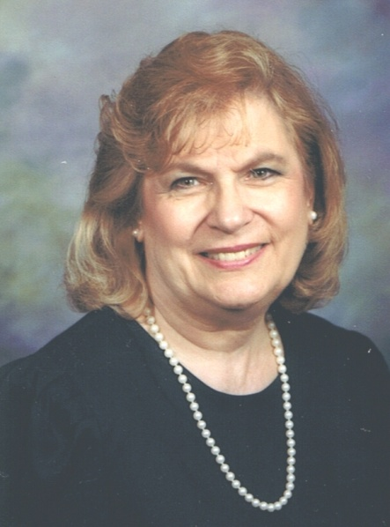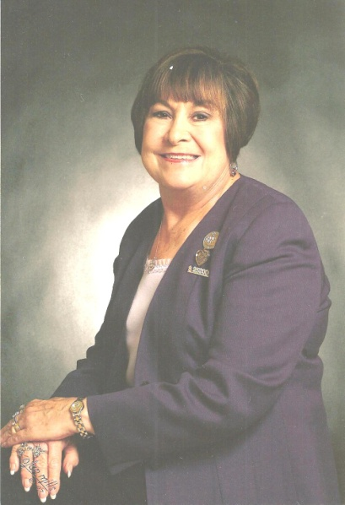
Queen Kay Childers No. 2 Judi Liles No. 3 Phyllis Jones
$20,463 Retail $16,463 Retail $15,827 Retail

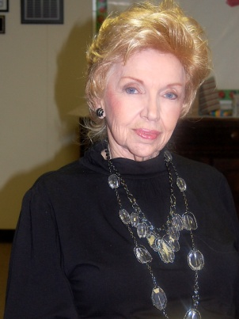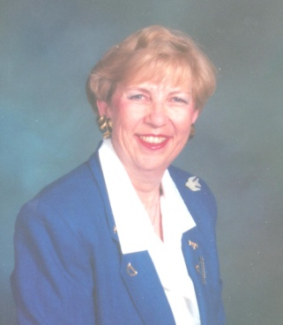
No. 4 Ruth Hise No. 5 Dolores Montoya No. 6 Gloria McCutcheon No. 7 Donna Canada
$9,692 Retail $8,077 Retail $7,635 Retail $6,745 Retail

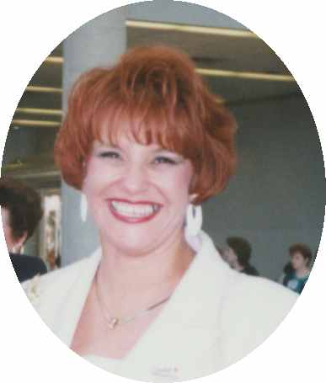
No. 8 Christine Castioni No. 9 Jackie Hatcher No. 10 Donna Cox
$6,708 Retail $6,310 Retail $5,913 Retail

. Galaxy of Stars (June 16, 2010 – June 15, 2011)

Become a consistent Star Consultant.
We can all achieve this.
We just need a plan and a commitment to stay focused when life hits us.

New Year
Be a Star Consultant all four quarters during the All-Star Star Consultant Consistency Challenge June 16, 2010 – June 15, 2011, and be rewarded with a sparkling bee charm.

New This Year…
All Pacesetting 4 quarter Star Angels this new year will be treated to dinner by Andrea at a Special restaurant on Day 00 of Seminar 2011.

What are the Star Levels?
Sapphire $1800 whls. During the Quarter
Ruby $2400 whls. During the Quarter
Diamond $3000 whls. During the Quarter
Emerald $3600 whls. During the Quarter
Pearl $4800 whls. During the Quarter

What are the Quarter Dates?
1st Quarter June 16 – Sept. 15
2nd Quarter Sept. 16 – Dec. 15
3rd Quarter Dec. 16 – March 15
4th Quarter March 16 – June 15

What Does It Take In Sales?
If you are already in the profit picture with $3600 whls. on your shelf, and you want to break the quarter down weekly with half profit and half reordering to replace your product sold you will want to do:
$300 weeks for Sapphire
$400 weeks for Ruby
$500 weeks for Diamond
$600 weeks for Emerald (National Court of sales)
$800 weeks for Pearl (National Court of Sales)

How many appointments do you need to hold each week to reach your goal?
$300 1 Good Party (3-4 faces) weekly
$400 2 Parties 4-6 faces weekly
$500 2 Good Parties 6-10 faces weekly
$600 3 Parties 10-12 faces weekly
$800 3 Good Parties or 4 Parties 12-15 faces weekly
Key – Have 2/3 of the number of appointments you plan to hold already ON your books by the lst of the month. To be held by the 18-20th. That gives you room to make up for any that don’t hold and time to book more for the rest of the month. Use the idea of giving the hostess a packet of Brownie mix and a crystal light lemonade in her hostess packet.

Monthly Party or Appointment Themes for August and September
Bronzing parties – start with Skin Care. Product Launch Parties – start with Skin Care. Summarize your Skin parties – start with skin care. Lipstick wardrobe parties. Spa Parties – tootsie rolls between the toes – ask them to bring their own favorite nail color – Satin hand and or sugar scrub. Portfolio Booking. Hot Mama. Hot Grandma. Women’s networking Portfolio, Hair color portfolio. New Looks portfolio. Party with a purpose. Give 10% to favorite charity. Coach. Get the guest list in 2-3 days. Get started or fill in by Hostessing your own parties. You can do this. I believe that it takes focus and follow thru. I believe in you. Love and hugs, Andrea

How to Coach Your Hostess!
By Natalie Reed

After booking the party/class tell her all about your Hostess Program! Ask her what she would love to earn with her hostess credit (skin care, glamour, microderm, etc.). You want her to get excited about the FREE stuff she will be earning. Then say, “It’s my job to make sure you reap all the rewards that we offer to our hostesses and so I’m going to make this super easy for you and mail out really cute invitations to your guests list. There is no expense to you and all you have to do is provide me with the mailing addresses and phone numbers of your guests. They are super cute and who doesn’t like to get something fun in the mail!? Would it be better for me to call you back or would you like to email me the list? Great, I will have a special gift for you (lipgloss, eye shadow, etc.) if you email me back within 48 hours with your guest list.”

Day 1 after booking the party, mail a HANDWRITTEN postcard that says: Thank you so much for hosting a party for me on __________. You are helping me reach my 100 faces goal. You make a difference in my business. I so appreciate you!

Day 3 after booking the party mail a copy of her customized glamour look (create on your www.marykayin intouch.com site) to her with a note (you can write the note right on the customized look paper!) saying: This is your new look. I am so excited to share it with you. Thank you again for helping me reach my 100 faces goal. You make a difference in my business. I so appreciate you! (This is only for hostesses who booked from a party or already had a skin care facial.)

Day 5 after booking the party, mail a package of Brownie or Cookie mix with Pink Lemonade with a note say: Here are some goodies to make the party easy for you. I know we are going to have so much fun. Again I can’t thank you enough because with you I couldn’t do my business.

You can get a box or bag of brownie or cookie mix and Crystal Light Pink Lemonade. I bought them at WALMART this week. The brownies are $1 and the Crystal light is $3.99 (8 packets-each packet makes a pitcher). Wouldn’t you be so excited to get this package in the mail. Trust me your hostess is going to be thrilled and there is no way she is going to cancel on you.

Jen Semelsberger, Executive Senior Sales Director, does this and has a 90% hold rate on all of her parties. That is awesome! Let’s all get booked up for August and coach those parties the right way.

After the party, mail a thank you note: Thank you so much for your help. You and your friends put me ____ faces closer to my 100 face goal. (Include a sincere compliment about her.) I so appreciate you and value you as my customer.

Take what you like from these ideas and use them to help you establish yourself with parties. These ideas will help you achieve your Star Consultant. Happy Booking and Coaching
Andrea
Fashion and the Platinum Rule
Image by Tia

Do you remember the Golden rue which is to treat others as you would want to be treated? Well now there is a new twist and it’s called The Platinum Rule, which says to treat others “How They Want To Be Treated.” So how do you know how someone wants to be treated and what does that have to do with fashion? It’s a bigger topic than I have room to write, so I will summarize the basics and remember that there are always exceptions. Generally speaking, we can break people down into four primary behavioral groups, and in my experience I have found several consistencies about how women dress within each category.

Directors: Are fast paced, task-oriented, decisive, competitive, leaders, goal setters and risk-takers. They talk more than listen and “they like to be treated like they are in charge”. Fashion Sense: Directors go for clean lines, strong colors, solids or strong prints and no-nonsense hair, make-up and accessories.

Relaters: Are observant, agreeable, warm, collaborative, thoughtful, cautious and good mediators. They listen more than they talk and “they want to be treated with compassion and cooperation”. Fashion Sense: Relaters like styles with flowing lines, prints with curvature and gentle or sunny colors. They wear simple accessories and hair and make-up is soft and approachable.

Thinkers: Are analytical, deliberate, thorough, calm, precise, logical and planners. They listen more than they talk, “want you to get to the point and not criticize their logic.” Fashion Sense: Thinkers wear understated colors and detailed prints. Their lines are clean (but can be a bit rumpled) and they wear smaller-scale accessories that are fairly simple in design and make-up is no fuss.

Socializers: Are outgoing, creative, fun spontaneous, fast paced, expressive, extroverted, energetic, persuasive and open to change. They talk more than they listen and “they want to be treated like a star”. Fashion Sense: Socializers love lots of color, solids and bold prints and clothes that are fun and exciting. They wear attention-getting accessories, often change out their look and experiment with hair and make-up.

I have found it very useful to think about the people in my life, both professionally and personally, in terms of the Platinum Rule and how they want to be treated. It’s something to think about!

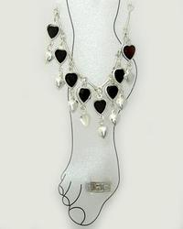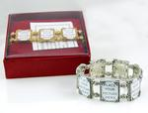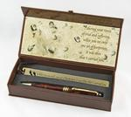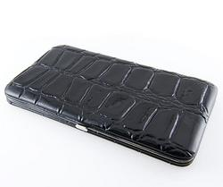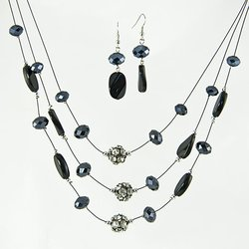
$250 Whls. Order $450 Whls. Order $600 Whls. Order $800 Whls. Order $1000 Whls. Order
Ankle Bracelet Photo Bracelet “Footprints Pen” Black Wallet Clutch Austrian Jet Crystals

$1,000 Wholesale – Kay Childers call and asked for the Pink Yurmanesque Moonstone Necklace and Judi Liles called and wanted the Austrian Crystal Cross Pin/Pendant Necklace.
$600 Wholesale – Crystal Star Necklace – Donna Canada, Gloria McCutcheon, Dolores Montoya, and Teresa Rubio
$450 Wholesale - Pink Yurmanesque Moonstone Necklace – Michelle Allen and
Ruth Hise
$250 Wholesale – Silver X Necklace - Billie Beckham, Pat Carrasco, Christine Castioni, Patricia Colbert,
Sharon Edwards, GBee Hamlin, Margot Howard, Phyllis Jones, Lynn Leonard, Karen Meno, Debra Southerland, Cruz Torres, Geneva Trujillo, Carla Villyard, and Julie White



Cutier than Cute Handbag

Chose your color in black, tan, turquoise or orange!

Happy Birthday
August Day
Magdalena T Arguello 1
Christy Fagan 4
Mary C. McNamee 4
Iris Cummins 5
LaRon Fulbright 11
Claudia K. Tufano 12
Jackie Hatcher 15
Jo L. Henderson 16
Debra D. Southerland 16
Joyce M. Foster 17
Vicki J. Thompson 19
Cheri Akers 24
Jennie L. Rodney 25
Kimberly A. Bauer 27
Ann B. Cobb 29

Mary Kay Anniversary
August Years
Lola M. Duran 19
Carolyn Simns 15
Sherri L. Allen 10
Carol A. Estebo 9
Debra D. Southerland 9
Margie J. Kitten 4
Geneva D. Trujillo 1
Bonnie L. Hobson 1
Anita L. Lucero 1

Your Guide to What’s Inside
August Hall of Fame (page1)
June Scoreboard (page 2)
Recruiter & their Teams (page 3)
Contest Status/Dear Angels (p. 4)
Top Ten in Sales (page 5)
Galaxy of Stars (page 6)

How to Coach Your Hostesses (p7)
Fashion the Platinum Rule (page 8)
August Promo/Prizes Won (p. 9)
Birthdays/Anniversaries (page 10)

You have the choice to be content with whatever happens, or you can set a goal and reach it, no matter what! You have the choice to listen to negativity, or you can develop a positive attitude. You have a choice to find excuses for not doing, or you can create a reason to achieve! You have the choice to use your children as an excuse, or you can show them how to work for what they want to achieve. It’s called lead by example. It’s your choice to be a success. Choose Seminar 2011 to be the Winner you envision yourself to be!

Andrea Pace, Future Executive Senior Sales Director
4206 Southfield Road
Ellicott City, Maryland 21042-5906
(410) 465-4442 or 1-800-863-2463
Fax No. (410) 313-9294; Cell Phone: (443) 980-7353
E-Mail Address – andrea@andreapace.com
Web Site for Andrea’s Consultants:
http://www.andreapace.com
Customer Website:
http://www.marykay.com/andreapace


“I ask only one thing from the Lord. This is what I want: Let me live in the Lord’s house all my life. Let me see the Lord’s beauty and look with my own eyes at his Temple.” Psalm 27:4

