Andrea's Pace-Setting Angels

$300,00 Circle of Achievement Unit
Chevy Equinox Unit

September 2010 Newsletter (July 2010 News)
Andrea Pace Unit 0154 -- 4206 Southfield Road, Ellicott City, Maryland 21042
Phone: (410) 465-4442 or 1-800-863-2463; FAX: (410) 313-9294;
Cell Phone: (443) 980-7353; Email: andrea@andreapace.com
Web site for Andrea’s Consultants: http://www.andreapace.com (Password: 0154)
Customer Website: http://www.marykay.com/andreapace

Welcome New Consultants
Lilian Alade (Clarksville, MD) – sponsored by Beryl Greenawalt

Welcome Back -- Reinstated Consultants
Sherri Allen (Artesia, NM) Iris Cummins (Forney, TX) Lola Duran (La Jara, NM)
Nancy Grissom (Seminole, TX) Lisa Heenan (Clovis, NM) Nancy Little (Memphis, TN)
Marilyn Nguty-Nkeng (Upper Marlboro, MD) Angela Sabourin (Catonsville, MD)

Hall of Fame for September 2010

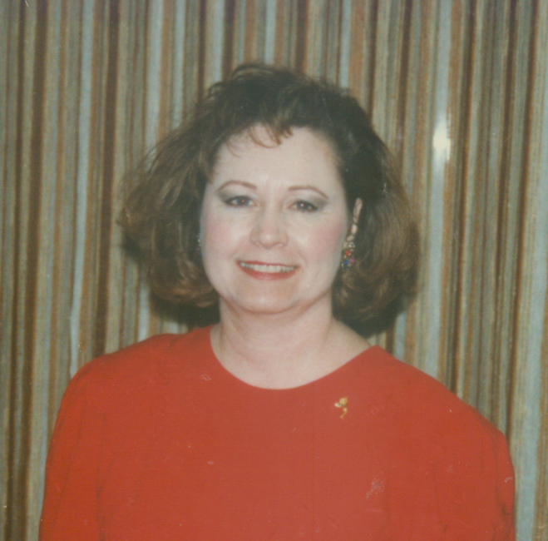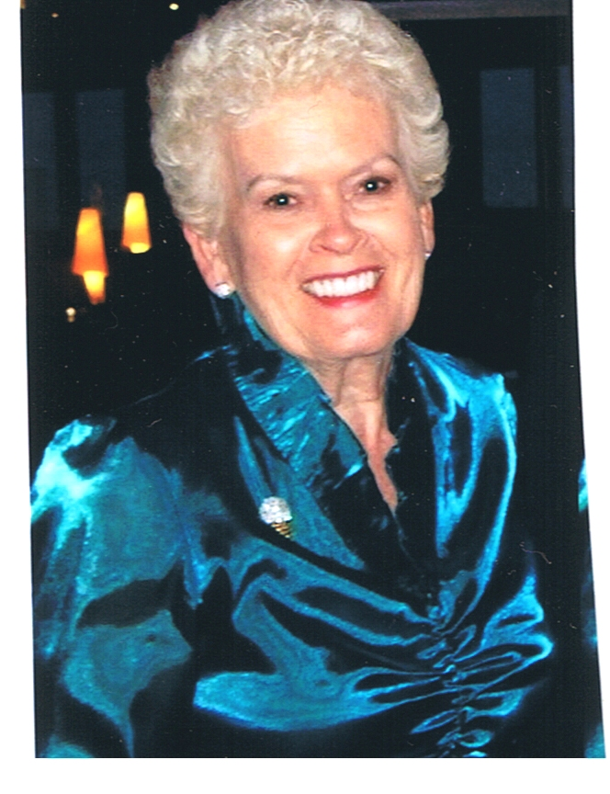
Nancy Grissom Eileen Hanson
$1,310 wholesale production $1,279 wholesale production


Beryl Greenawalt
One July Recruit
July 2010 Scoreboard

Consultants Ordering In July 2010 Queen Nancy Grissom-- $1,310

Sherri Allen
Donna Canada
LaJoyce Cannon
Christine Castioni
Donna Cox
Iris Cummins
Lola Duran
Candace Entingh
Christy Fagan
Becky Farris
Beryl Greenawalt
Nancy Grissom
Eileen Habsib
Sandra Hauer
Lisa Heenan
Patricia Holt
Phyllis Jones
Margie Kitten
Judi Liles
Nancy Little
Nina Mack
Dolores Montoya
Jana Morgan
Marilyn Nguty-Nkeng
Andrea Pace
Angela Sabourin
Vicki Thompson
B.J. Watson
Mary Welter
Julie White

Eileen Hanson -- $1,279
Judi Liles -- $600

Court of Sharing (Year to 7/31/2010)

Beryl Greenawalt - 1

Year to Date Retail Production (thru July 31st)
1 Judi Liles $3,835.50
2 Nancy G. Grissom $2,705.50
3 Eileen Hanson $2,696.50
4 Donna Canada $2,286.50
5 Dolores M. Montoya $2,041.00
6 Christine T Castioni $1,324.00
7 Phyllis A. Jones $1,317.00
8 Julie K. White $916.00
9 Lola M. Duran $882.00
10 Jana R. Morgan $825.50
11 Donna G. Cox $818.00
12 Sherri L. Allen $666.00
13 Margie J. Kitten $659.50
14 Mary L. Welter $638.00
15 Candace D. Entingh $628.50
16 Nancy C. Little $589.00
17 B.J. Watson $576.00
18 Beryl A. Greenawalt $573.00
19 LaJoyce M. Cannon $573.00
20 Vicki J. Thompson $503.00

Andrea Pace $2,450.00
Consultants with
July Recruiter Commissions

9% Recruiter Commission Level
Judi Liles
Jackie Hatcher
Andrea Pace
Donna Canada
Beryl A. Greenawalt

4% Recruiter Commission Level
Christine T Castioni
Ruby F. Hulett
Phyllis A. Jones
Candace D. Entingh
Sharon A. Edwards

Total Unit Retail Production
July 2010 -- $20,025
Seminar Year -- $20,025

Recruiters and their Teams (as of July 31, 2010)

Future Sales Director
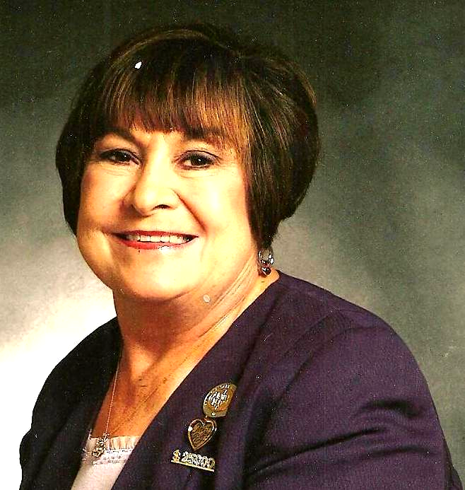
Recruiter: Judi Liles
Helen Bearden
Brandy M. Blount
LaJoyce M. Cannon
Iris Cummins
Patricia A. Holt
Virginia L. Jones
Marilee Mandernach
Carla A. Villyard
B.J. Watson
* Cheri Akers
* Kimberly A. Bauer
* Jody O. Colwell
* Jo L. Henderson
* Barbara Kelly
* Martha J. Lange
* Robbie F. Litzman
* Bobbie L. Merritt
* Carol F. Sanders
* Melba J. Williams
* MaryAnn Youngblood

Team Leaders
Recruiter: Beryl A. Greenawalt
Sharon L. Dixon
Bee A. Hamlin
Nancy L. Norris
Angela M. Sabourin
Crystal D. Watson
* Lilian Alade
* Betty M. Everett
* Sandra Gutierrez
* Clola M. Robnson

Team Leaders

Recruiter: Jackie Hatcher
Yvette A. Birch
Donna G. Cox
Joyce Johnson
Sandra L. Schillizzi
Susan C. Wesner
Helen Westlund

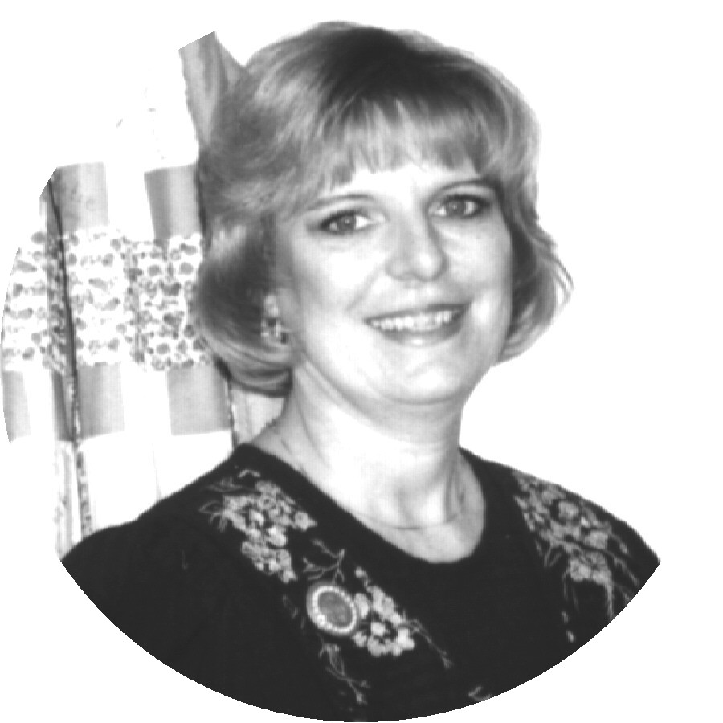
Recruiter: Donna Canada
Sherri L. Allen
Donna K. Gray
Cody Hanagan
Linda S. Richardson
Teresa G. Rubio

Star Team Builders

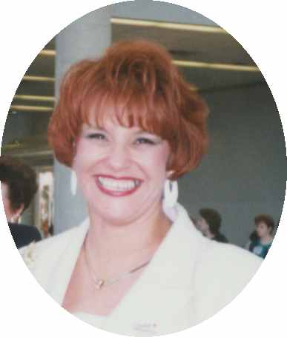
Recruiter: Christine T. Castion
Eileen Hanson
Lisa Heenan
Dolores M. Montoya
Cruz P. Torres
* Carol A. Estebo
* Sandy Flores

- = inactive Consultant
Senior Consultants
Recruiter: Bonnie Montgomery
Nancy G. Grissom
Debra D. Southerland
* Doreta Higginbotham
* Jana D. Laubscher

Recruiter: Candace D. Entingh
Tena K. McElvain
Mary L. Welter

Recruiter: Cheri Akers
Karen R. Meno

Recruiter: Delma C. Aranda
Pat Carrasco

Recruiter: Eileen Hanson
Geneva D. Trujillo

Recruiter: Helen Bearden
Ruth H. Hise
Kaye Richardson

Recruiter: Mary L. Welter
Magdalena T Arguello
* Taffee Anhder
* Gabriele I. Trujillo

Recruiter: Phyllis A. Jones
C. Anderson Fagan
Margie J. Kitten
* Ellen H. Wallace

Recruiter: Ruby F. Hulett
Phyllis A. Jones

Recruiter: Sharon A. Edwards
Julie K. White

3rd Quarter Star Consultant Promotion
Promotion starting 6/16/10 – ending 9/15/10 (as of August 26, 2010)
************** Needed for Star **************
Consultant For Star Sapphire Ruby Diamond Emerald Pearl
Judi Liles | $1,909.25 | STAR | $490.75 | $1,090.75 | $1,690.75 | $2,890.75
Jackie Hatcher | $1,426.25 | $373.75 | $973.75 | $1,573.75 | $2,173.75 | $3,373.75
Nancy Grissom | $1,310.75 | $489.25 | $1,089.25 | $1,689.25 | $2,289.25 | $3,489.25
Eileen Hanson | $1,279.25 | $520.75 | $1,120.75 | $1,720.75 | $2,320.75 | $3,520.75
Ruth Hise | $1,124.00 | $676.00 | $1,276.00 | $1,876.00 | $2,476.00 | $3,676.00
Gloria Mccutcheon | $1,114.25 | $685.75 | $1,285.75 | $1,885.75 | $2,485.75 | $3,685.75
Phyllis Jones | $1,042.75 | $757.25 | $1,357.25 | $1,957.25 | $2,557.25 | $3,757.25
Beryl Greenawalt | $882.00 | $918.00 | $1,518.00 | $2,118.00 | $2,718.00 | $3,918.00
Andrea Pace | $827.75 | $972.25 | $1,572.25 | $2,172.25 | $2,772.25 | $3,972.25
Teresa Rubio | $715.75 | $1,084.25 | $1,684.25 | $2,284.25 | $2,884.25 | $4,084.25
Donna Canada | $705.00 | $1,095.00 | $1,695.00 | $2,295.00 | $2,895.00 | $4,095.00
Christine Castioni | $701.00 | $1,099.00 | $1,699.00 | $2,299.00 | $2,899.00 | $4,099.00
Bee Hamlin | $628.75 | $1,171.25 | $1,771.25 | $2,371.25 | $2,971.25 | $4,171.25
Jana Morgan | $605.00 | $1,195.00 | $1,795.00 | $2,395.00 | $2,995.00 | $4,195.00
Lola Duran | $559.75 | $1,240.25 | $1,840.25 | $2,440.25 | $3,040.25 | $4,240.25
Dolores Montoya | $558.50 | $1,241.50 | $1,841.50 | $2,441.50 | $3,041.50 | $4,241.50
Candace Entingh | $535.50 | $1,264.50 | $1,864.50 | $2,464.50 | $3,064.50 | $4,264.50
Patricia Colbert | $503.00 | $1,297.00 | $1,897.00 | $2,497.00 | $3,097.00 | $4,297.00
Julie White | $450.00 | $1,350.00 | $1,950.00 | $2,550.00 | $3,150.00 | $4,350.00
Nancy Sweet | $409.00 | $1,391.00 | $1,991.00 | $2,591.00 | $3,191.00 | $4,391.00
Donna Cox | $401.00 | $1,399.00 | $1,999.00 | $2,599.00 | $3,199.00 | $4,399.00

Dear Angels,
I am so excited! I ordered a new Beauty Case.! Any of you that want to do this, just let me know and I will order the $100 Beauty Case for you. Just give me your Credit Card Number and we will be good to go.
Since I last emailed you, I have 9 woman who will bring a couple of their friends over for a facial. Wonderful! My first party, I held after arriving home at midnight from visiting my sisters and nieces in California. (It seems we are calling them parties instead of shows now.) So much has changed since my last Beauty Case. The mirrors and trays are so cute and easy to use. I just followed the flip chart. My sister Angela told me that she started out by saying, “We were going to play like we are in the third grade. I will read to you and you will look at the pictures and turn the pages in your Beauty Book.
It was so simple and a piece of cake. Of course I asked for God’s help that I would be able to help them with their skin care needs. I truly had no expectation on the sales amount. I did tell my hostess that she had a choice of 10% of my profit to her favorite charity or 50% off of anything she wanted to buy. I also gave her a small gift in front of everyone.
Well we all had a ball and my sales were $400. I was thrilled and Dale was too. He just clapped his hands for me. I had 5 ladies there and three of them purchased skin care TimeWise. The others just bought different supplements and glamour. It was fun and I encourage you to do this for Mary Kay’s grandson, Ryan. I feel she was watching me from heaven and was smiling down on me with my efforts to help her grandson and our company reach our goals. Just see what it will bring to you and your family in extra income and personal satisfaction. Love to you all,
Andrea

Holding Shows – Operation Profit from Liz Daniels

Consultants I know many of you are working to build your inventory and a nice customer base. Thought you would enjoy some of Liz’s blogging that she has done this month in making her $1285 house payment NOT from her nice Cadillac, $500,000, unit club Director check but from her sales without recruiting commission.
If you were at our Monday Night meeting last week, you heard my passion on the topic of seeing a profit in your business. In light of what each person is working for (I challenged every Consultant to decide on a profit amount you want weekly with your business and then decide what you are going to do with the money!), I have decided to let you gals take a peek at my profit for the month of July. I announced to the group that my goal is to have the profit from my sales and pay my mortgage for my August 1st payment! My payment is $1285 and here is how things are going:
5 classes held so far: $1275 Reorders: $338 Faces: 33 (not counting any at events for Consultants)
Hours: 13 Total Sales: $1613 Reorder Total: $900 Profit: $645 (yippee! half of my house payment)
Income per hour: $49.60 an hour
Today is the 19th and I have 4 possibly 5 more classes on my books for July. This business does work when it is worked!
Just a side note to how I have arrived with 10 classes on my date book in July. In April, the only thing I focused on was a power start - 30 faces. At each appointment, my goal was to get 2 bookings. My face total in April was 24! In May, again my only focus was to do 30 faces and 2 bookings from each class. I did 32 faces! June, what a lovely month! I did 65 faces and held 10 classes. My sales were over $4000! Again, this business works when it is worked! Rome was not built in a day! I built upon my April activity to make my power start a power zoom! Now I stand in July with 10 classes on my books and 6 already on my books for August! My only complaint is that I am having to hire more help! What an excellent problem to have! I made a decision. What is yours? What type of weekly profit do you want or need for your family? Are you scratching your head right now wandering about how you are going to buy school clothes, school supplies? You should see my kids list!? Don't be starving in an orchard.
Now let's review the profit on a star week. Choose you this day which profit you want! I know that together, we can make great things happen:
*Keep in mind that there are 12 weeks in a quarter (3 months): Sell $275 a week to be a Sapphire Star. Hey Beelievable Achievable! This is only one class per week with reorders. One Consistent class per week - That is $110 in profit for week and $440 for the month.
Sell $350 a week to be a Ruby Star - Hey Girl! That isn't even 2 classes a week and reorders...Go for it! Consistent class per week...That is a profit of $140 a week and $560 a month - bill money!
Sell $500 a week to be a Diamond Star - Diamonds are a girl's best friend! This is 2 classes a week - Consistent classes per week! That is a profit of $200 a week and $800 a month...That would be a house payment!
Sell $600 a week to be an Emerald Star – You are movin' and groovin' now! This is 2 to 3 classes a week and a minimum of $240 profit a week for an extra $960 cash a month for your family. That is almost $1,000 bucks! What would you do with it?
Sell $750 a week to be a Pearl Star - Holy Smokes! You have arrived at some serious cash! This is 2 to 3 classes per week with a minimum of $300 profit a week and an extra $1200 in cash a month for your family! Consistency is the key...bee consistent!

This is not for the chosen few...but the few who choose!

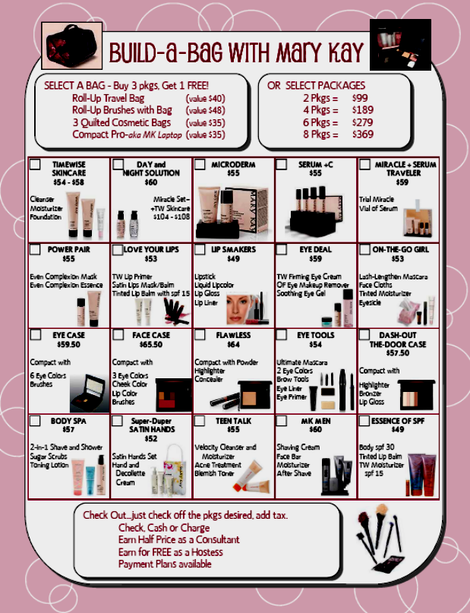
Words to use for Julie’s Build a Bag Packages
TW Skincare - $54 or $58 with Mineral powder: Basic to get started on good skin care - Like an aerobic workout, but sometimes you need to spot treat. Use with the foundation for maximum results.
Day/Night Solution - $60: This is your Repair and Prevention. Day Solution brightens, blocks uva-uvb rays while relaxing facial lines. Night Solution has unique encapsulated vitamins and antioxidants that stimulates collagen to firm the skin.
Microdermabrasion Step 1 and 2 - $55: Immediately fights fine lines, refines pores and smoothes your skin with a Refine polish than a botanically filled Replenish serum.
Replenishing Serum + C - $55: Packed wit5h Super Fruits to give your collagen a boost. Leaves your skin lifted, more toned, looking younger and enhanced.
Miracle Plus Serum Traveler - $59: Trial/Travel size of the Miracle plus a Vial of the Serum. Great for trips or to give it a try and you’ll see the results.
Power Pair: Even complexion Mask and Essence for $55: Mask pampers, brightens and softens with Melacep Brightening complex and 90% saw softer/brighter skin. Essence has Lucentrix Complex to restore skin tone with. 84% saw improvement.
Love Your Lips: Primer, Satin Lips and Tinted Lip Balm with spf 15 in a color of your choice - $53: Primer minimizes lines and keeps lip color on longer. Satin Lips is a 2 step scrub and balm then top with spf protection and a tint of color.
Lip Smakers: Lipstick, Liquid Lip Color, Lip Gloss and Lip Liner - $49: Create a variety of options.
Eye Deal: Firming Eye Cream, Eye Make Up Remover, Soothing Eye Gel - $59: Moisturize and Firm the eye area. Remove makeup gently, then pamper with the Gel Filled with botanicals like cucumber and green tea plus increases moisturization up to 130%.
On the Go Girl: Facial Cleansing cloths, Tinted Moisturizer, Mascara and Eyesicle - $53: Quick wash of the face and add a Tinted Moisturizer with spf 15 then Eyesicle and Mascara – out the door you go!
Eye Case: Compact with 6 eye colors - $59.50: Fill up your sleek Compact with all Eye colors. For just 6.50 each you can add 5 more to the brush area for 11 eye colors. Brow gel fits in the top!
Face Case: Compact with 3 eye colors, Cheek color, Lip Gloss/Color and brushes for $65.50: Magnetized Compact lets you create/recreate new looks. And the mirror is large enough for your whole face.
Flawless: Pressed mineral powder in a compact with sponge plus Highlighter and Concealer - $64: Get an airbrushed look with these 3 Amigos. Powder to freshen up your foundation. Highlighter for eyes and fine lines. Concealer for blemishes and unwanted spots.
Eye Tools: Ultimate Mascara, 2 eye colors, brow tools, eyeliner, eye primer - $54: Perfect set to create the perfect eye look. You can add more colors or a compact for more fun.
Dash Out the Door Case: Highlighter and Bronzer plus Lip Gloss - $57.50: Highlighter and Bronzer has strips of color for cheeks & for the eyes. Finish with Gloss and maybe some mascara and you are on your way.
Body Spa: 2 in 1 Shave and Shower gel with Sugar Scrubs and TimeWise Toning Lotion - $57: Talk about the ultimate! Shave and shower then Scrub away the dead skin. Top with the Targeted Toning Lotion and your skin will never feel the same. Lotion will firm, tone, define, soften and hydrate for 24 hours! Powered by Super fruits and caffeine.
Super Duper Satin Hands: 3 step Satin Hands plus TimeWise Hand and Decollete Cream - $52: Satin hands for the ultimate hand and feet pampering is paired with the Hand and Decollete cream with spf15. Powered by Super Fruits to minimize crepiness, reduce dark spots and super hydrate hands and chest.
Teen Talk: Velocity Cleanser and Moisturizer designed for skin under 25 plus Acne Treatment and Blemish Control toner - $55: MK’s version of Proactive. Controls and zaps acne while cleansing, hydrating and controlling excess oil. This is great for boys too especially since orange and “velocity”.
MK Men: Shaving Cream, Face Bar, Moisturier with spf 25 and Cooling After-Shave - $60: Don’t forget about the man in your life – keep him looking as young as you & providing a comfort zone while shaving.
Essence of SPF: Body with spf 30, Tinted Lip Balm with spf 15 & TimeWise Moisturizer with spf 15 - $49: From Head, Lips to Toes – protect your skin from daily damage of walking your dog to driving your car.

New for the Seminar 2011 Year! Do at least two of the five, to qualify for Andrea’s Inner Circle each month! Your picture will be in Andrea’s Hall of Fame for that Month in the newsletter on the front page and you will receive a special gift from me. Completing the Elite Inner Circle – all five of the challenges will help you build your business quickly and you will be awarded something extra special! This will certainly make you a “Woman of Excellence”. Fill out this page with names and retail sales and wholesale amounts and return to me at the end of each month to receive your rewards!

Put product on at least 8 people:
1.________ 2._________ 3._________ 4.________ 5.___________ 6.__________ 7.__________

8.________ 9._________ 10.________ 11.________ 12.________ 13.________ 14.________

Team Building: 2 or more interviews or guest who listen to marketing plan:
1.________ 2._________ 3.________ 4.________ 5._________ 6._________ 7._________

One New Team Member: 1. __________

$800 or more in Retail Sales: Total sales amount $_______

$400 or more in Wholesale Orders: Total wholesale amount $_____

I am a Member of Andrea’s Inner circle: ________________________________
(Sign Your Name)

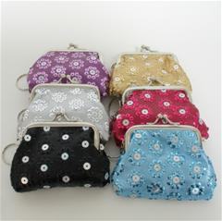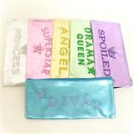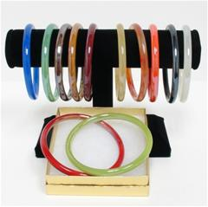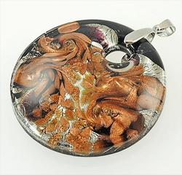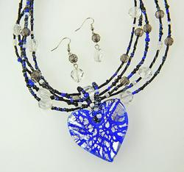
$250 Wholesale $450 Wholesale $600 Wholesale $800 Wholesale $1,000 Wholesale
Glitz Coin Purse Money Bag 2 Glass Bracelets Moreno Black Moreno Glass Dark
Metallic Necklace Blue Heart Set

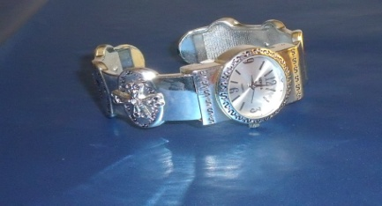
When you Hold your 10th Party with at least 3 people at each Party, you will receive a beautiful Silver Bracelet Watch with words of Faith, Hope, and Love on the Side of the Watch. This will help Ryan Rogers, Mary Kay’s Grandson in His goal of leading our company to the 5 Billion in Sales by 2013 - our 50th Anniversary! Just call me and let me know that you have held the shows and entered them on MK Intouch show count.


New Yearly Consistency Award: The first year you can earn the White Gold Add-A-Diamond Ring. Each year after, you earn a 5 point Diamond to be added to your Ring.

To win the Yearly Consistency Award you must order at least $250 wholesale per month for 9 of the 12 months. You also must have a total of $4,800 wholesale ($9,600 retail) by the end of the year to win the Add-A-Diamond or to win the 5 pt. Diamond. You may order as many months as you need to total $4,800 wholesale/$9,600 retail for the year. Watch this area of the newsletter for the updated list of all consultants on pace for the 2010-2011 Consistency Contest! Consultants whose total wholesale of $18,000/36,000 retail will earn a 15 pt. Diamond. Consultants on target in July are below:

$1,000+ wholesale – Murano Glass Earrings – Nancy Grissom and Eileen Hanson
$600+ wholesale – Extreme in Silver Earrings – Judi Liles
$250+ wholesale – Western Jeans Earrings – Sherri Allen, Donna Canada, LaJoyce Cannon, Christine Castioni, Donna Cox, Lola Duran, Candace Entingh, Beryl Greenawalt, Phyllis Jones, Nancy Little, Jana Morgan, Vicki Thompson, and Mary Welter

Achieve by September 9/15/2010 and receive “Cute Handbag”.

Happy Birthday
September Day
Linda S. Richardson 1
Justine Schaeffer 1
Joker Ward 2
Lynda I. Boland 17
Koreasa M. Williams 21
Judith F. Weiner 28

Mary Kay Anniversary
September Years
Andrea Pace 44
Becky L. Farris 33
Jana R. Morgan 28
Sharon A. Edwards 25
Dolores M. Montoya 24
Patricia A. Holt 21
Beverly L. Guthrie 20
Bee A. Hamlin 11
Gingmon T. Randolph 5
Kenda J. Thvedt 5
Sandra Gutierrez 4
Iris Cummins 1
Justine Schaeffer 1

Your Guide to What’s Inside
September Hall of Fame (page1)
July Scoreboard (page 2)
Recruiter & their Teams (page 3)
Contest Status/Dear Angels (p. 4)
Holding Shows (page 5)
Build a Bag with MK (page 6)

Words to Use (page 7)
Andrea’s Inner Circle (page 8)
Sept Promo/Prizes Won (page 9)
Birthdays/Anniversaries (page 10)

Preferred Customer Unit Participation for the Fall/Holiday 2010

Michelle Allen
Christa Brack
Kay Childers
Donna Cox
Beryl Greenawalt
Bee Hamlin
Eileen Hanson
Sandra Hauer
Phyllis Jones
Judi Liles
Gloria McCutcheon
Mary McNamee
Jana Morgan
Andrea Pace
Claudia Tufano
B.J. Watson
Susan Wesner

Andrea Pace, Future Executive Senior Sales Director
4206 Southfield Road
Ellicott City, Maryland 21042-5906
(410) 465-4442 or 1-800-863-2463
Fax No. (410) 313-9294; Cell Phone: (443) 980-7353
E-Mail Address – andrea@andreapace.com
Web Site for Andrea’s Consultants:
http://www.andreapace.com
Customer Website:
http://www.marykay.com/andreapace



Proverbs 27:19 “As water reflects your face, so your mind shows what kind of person you are.”

