Andrea's Pace-Setting Angels

$300,00 Circle of Achievement Unit
Chevy Equinox Unit

November 2010 Newsletter (September 2010 News)
Andrea Pace Unit 0154 -- 4206 Southfield Road, Ellicott City, Maryland 21042
Phone: (410) 465-4442 or 1-800-863-2463; FAX: (410) 313-9294;
Cell Phone: (443) 980-7353; Email: andrea@andreapace.com
Web site for Andrea’s Consultants: http://www.andreapace.com (Password: 0154)
Customer Website: http://www.marykay.com/andreapace

Welcome New Consultants
Brenda Green (Dallas, TX) – Sponsored by Judi Liles

Welcome Back -- Reinstated Consultants
Taffee Anhder (Colorado Springs, CO) Jo Henderson (McKinney, TX)
Bonnie Hobson (Lacygne, KS) Sue Robertson (Chestertown, MD)
Justine Schaeffer (Ellicott City, MD) Ellen Wallace (Lubbock, TX)

Hall of Fame for November 2010

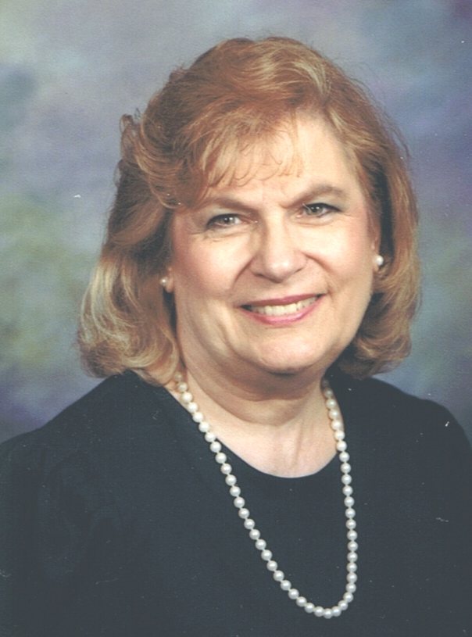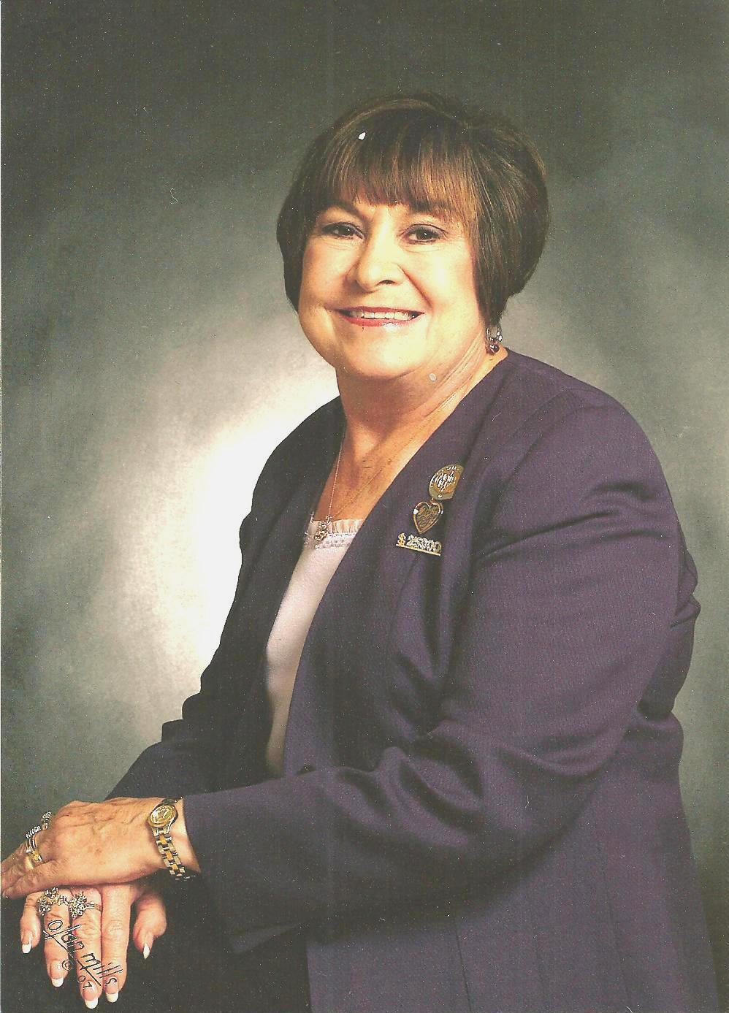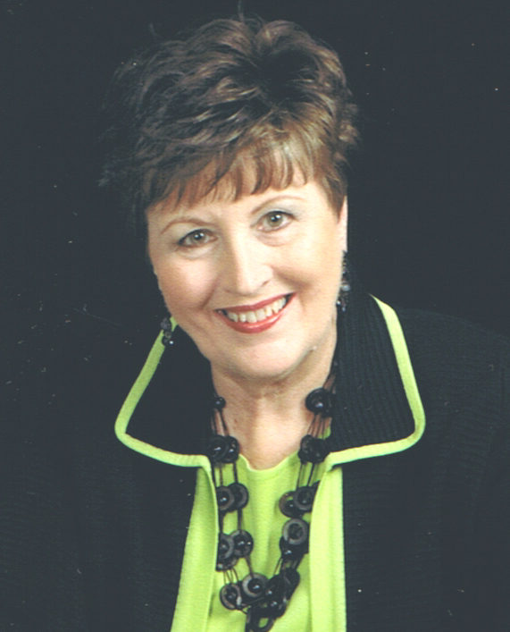
Kay Childers Judi Liles Andrea Pace
$1,561 wholesale production One September Recruit $1,124 wholesale production

September 2010 Scoreboard

Consultants Ordering In September 2010 Queen Kay Childers -- $1,561

Cheri Akers
Michelle Allen
Taffee Anhder
Magdalena Arguello
Donna Camada
Kay Childers
Ann Cobb
Patricia Colbert
Sharon Edwards
Joyce Foster
LaRon Fulbright
Rhonda Gover
Cody Hanagan
Eileen Hanson
Jackie Hatcher
Jo Henderson
Ruth Hise
Bonnie Hobson
Ruby Hulett
Phyllis Jones
Nina Mack
Gloria McCutcheon
Bobbie Merritt
Bonnie Montgomery
Dolores Montoya
Nancy Norris
Andrea Pace
Sue Robertson
Cruz Torres
Gabriele Trujillo
Ellen Wallace
Joker Ward
B.J. Watson
Mary Welter
Melba Williams
Justine Zchaeffer

Phyllis Jones -- $643
Eileen Hanson -- $603

Andrea Pace -- $1,095

Court of Sharing (Year to 9/30/2010)

Beryl Greenawalt – 1
Judi Liles -- 1

Year to Date Retail Production thru 9/30/2010
1 Kay Childers $7,156.00
2 Judi Liles $5,552.00
3 Jackie Hatcher $4,046.50
4 Eileen Hanson $3,964.00
5 Phyllis A. Jones $3,734.00
6 Ruth H. Hise $3,713.00
7 Dolores M. Montoya $3,408.00
8 Donna Canada $3,051.50
9 Gloria K. McCutcheon $2,954.50
10 Nancy G. Grissom $2,705.50
11 Patricia R. Colbert $2,266.50
12 Michelle E. Allen $2,230.00
13 Beryl A. Greenawalt $1,971.00
14 Christine T Castioni $1,906.00
15 Donna G. Cox $1,533.50
16 Teresa G. Rubio $1,447.50
17 Sharon A. Edwards $1,297.00
18 Bee A. Hamlin $1,257.50
19 Jana R. Morgan $1,226.00
20 Joker Ward $1,216.00

Andrea Pace $8,185.00
Consultants with
September Recruiter Commissions

9% Recruiter Commission Level
Judi Liles
Jackie Hatcher
Beryl A. Greenawalt

4% Recruiter Commission Level
Christine T Castioni
Andrea Pace
Mary L. Welter
Ruby F. Hulett
Phyllis A. Jones
Sharon A. Edwards
Candace D. Entingh
Donna Canada

Total Unit Retail Production
September 2010 -- $24.059
Seminar Year -- $94,677

Recruiters and their Teams (as of September 30, 2010)

Future Sales Director
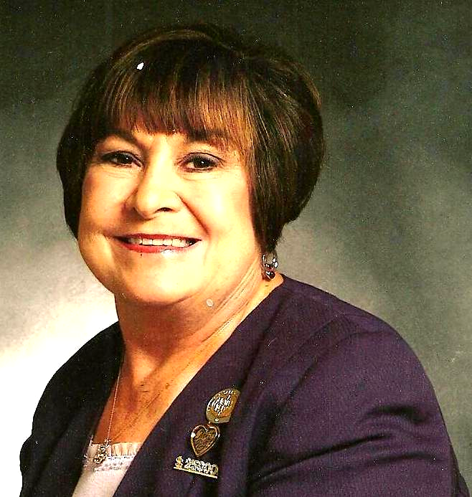
Recruiter: Judi Liles
Cheri Akers
Brandy M. Blount
LaJoyce M. Cannon
Iris Cummins
Jo L. Henderson
Barbara Kelly
Martha J. Lange
Bobbie L. Merritt
Carol F. Sanders
B.J. Watson
Melba J. Williams
* Kimberly A. Bauer
* Helen Bearden
* Brenda Green
* Patricia A. Holt
* Virginia L. Jones
* Marilee Mandernach
* Carla A. Villyard

Team Leaders 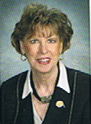
Recruiter: Beryl A. Greenawalt
Lilian Alade
Sharon L. Dixon
Bee A. Hamlin
Nancy L. Norris
Clola M. Robinson
Angela M. Sabourin
* Crystal D. Watson

Team Leaders

Recruiter: Jackie Hatcher
Yvette A. Birch
Donna G. Cox
Joyce Johnson
Sandra L. Schillizzi
Susan C. Wesner
* Helen Westlund

Star Team Builders


Recruiter: Mary L. Welter
Taffee Anhder
Magdalena T Arguello
Gabriele I. Trujillo

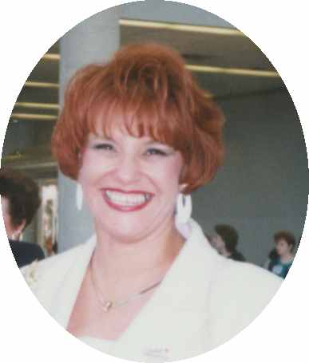
Recruiter: Christine T. Castion
Eileen Hanson
Lisa Heenan
Dolores M. Montoya
Cruz P. Torres

- = inactive Consultant
Senior Consultants
Recruiter: Bonnie Montgomery
Nancy G. Grissom
* Debra D. Southerland

Recruiter: Candace D. Entingh
Tena K. McElvain
Mary L. Welter

Recruiter: Cheri Akers
Pamela White
* Karen R. Meno

Recruiter: Donna Canada
Sherri L. Allen
Cody Hanagan
* Donna K. Gray
* Linda S. Richardson
* Teresa G. Rubio

Recruiter: Helen Bearden
Ruth H. Hise
* Kaye Richardson

Recruiter: Lynda I. Boland
Beverly L. Guthrie

Recruiter: Margot Howard
Bonnie S. Morrison
Justine Schaeffer

Recruiter: Phyllis A. Jones
Christy Fagan
Ellen H. Wallace
* Margie J. Kitten

Recruiter: Ruby F. Hulett
Phyllis A. Jones

Recruiter: Sharon A. Edwards
Bonnie L. Hobson
* Julie K. White

Star Consultant Contest Status
For Contest Ending December 15, 2010 (as of October 20, 2010)

*************** Needed for Star ***************
Consultant In for Star Sapphire Ruby Diamond Emerald Pearl
Phyllis Jones | $916.00 | $884.00 | $1,484.00 | $2,084.00 | $2,684.00 | $3,884.00
Andrea Pace | $711.25 | $1,088.75 | $1,688.75 | $2,288.75 | $2,888.75 | $4,088.75
Patricia Colbert | $465.25 | $1,334.75 | $1,934.75 | $2,534.75 | $3,134.75 | $4,334.75
Christine Castioni | $452.50 | $1,347.50 | $1,947.50 | $2,547.50 | $3,147.50 | $4,347.50
Sue Robertson | $452.25 | $1,347.75 | $1,947.75 | $2,547.75 | $3,147.75 | $4,347.75
Laron Fulbright | $427.75 | $1,372.25 | $1,972.25 | $2,572.25 | $3,172.25 | $4,372.25
Dolores Montoya | $424.50 | $1,375.50 | $1,975.50 | $2,575.50 | $3,175.50 | $4,375.50
Ann Cobb | $400.50 | $1,399.50 | $1,999.50 | $2,599.50 | $3,199.50 | $4,399.50

Dear Angels,
This newsletter is pack full with good information.
Read all about the new TimeWise Liquid Foundations which you will be able to order on January 19, 2011. The enclosed article will give you all the facts. It is very exciting to me and I can hardly wait to start using and selling these new foundations.
I am thrilled over the article entitled “The Fountain of Youth! I have always used the Microdermabrasion 3 times a week and my skin looked fabulous. Always apply to a wet face. I use it immediately after cleansing my face. Now I plan to use the this every other day and the in between days use the Even Complexion Mask. It is so easy to use. While I let it dry for the 10 to 15 minutes, I too get more stuff done. I sure want to look as good as Denise!
Now did you know that you can “Build your own Travel Bag” for your Shows. Sometimes I am a slow learner where computers are concern. When you do this on your own computer, your own name will come up where it says, ”Contact me to order!” To get the Get Set For Beauty” log into Intouch. Click on Business Tools, Choose - Build your Own – Brochure – Travel Roll-Up Bag. Add the Sets in this order. Time-Wise Replenishing Serum+C (this will go in A section), next Even Complexion Mask (this will go into the B section), next TimeWise Body Care Set (this will go into C section), next complete Color Set (this will go into the D and F sections), and last Oil and Blemish Control Set (this will go into the E section.) Then click on next step. There you have it. Save and Print!!!!! Fabulous!
I plan to hold my Open House on November 13th. I keep my open house extremely simple. I just offer all my Customers 20% off of everything. This is my thank you gift to them for their continued business all year long. I will let you know how it turns out.
Have a blessed Thanksgiving. It is wonderful being with all our families,
Andrea
New TimeWise Liquid Foundations Are Coming!

By now you may have already heard the news that new age-fighting foundations will be added to the Mary Kay line in which you can order on January 19, 2011.
These new TimeWise Liquid foundations (TimeWise Luminous-Wear for normal to dry skin and TimeWise Matt-Wear fro combination to oily skin) will provide additional choices to customers and allow you to become expert foundation finders, matching each woman to the product that’s right for her! What’s more, the age-fighting benefits of these foundations will make them an essential “fifth step” of the TimeWise Miracle Set and boost your sales potential!

TimeWise Liquid Foundations Formulas – These foundations are formulated to help fight the signs of aging and include a patented blend of collagen-building peptides and vitamin E. These beauty multi-taskers provide skin care benefits along with beautiful coverage and come in 23 shades to match a wide variety of skin tones. Both products also provide many benefits that complement the benefits of the Mary Kay TimeWise Miracle Set.

TimeWise Luminous-Wear Liquid Foundation – Visibly reduces the appearance of pores, fine lines, wrinkles and skin imperfections. A moisturizing complex enriched with skin-loving jojoba delivers lasting comfort and hydration. Provides immediate hydration and leaves skin with a touch of radiance, luminosity and brightness. Suggested retail price: $20.

TimeWise Matt-Wear Liquid Foundation – Visibly reduces the appearance of pores, fine lines, wrinkles and skin imperfections. Special microspheres work all day to absorb oil and control shine without a heavy makeup look or feel. Provides immediate mattifying benefits and leaves skin with a satin, matte finish. Suggested retail price: $20.
New TimeWise Liquid Foundation samplers (strip of six; three each Luminous Wear and Matte-Wear, $1 will be available on Section 2.

A Flawless Finish – A new Mary Kay Foundation Primer and Mary Kay Liquid Foundation Brush will launch along with the new TimeWise Liquid Foundations.
The Mary Kay Foundation Primer enhances foundation benefits and extends the wear of foundation. It can be used with any Mary Kay foundation and glides on like a dream so makeup applies smoothly and blends easily. The Mary Kay Foundation Primer has a suggested retail price of $20.
The Mary Kay Liquid Foundation Brush works like a paintbrush on canvas, depositing the right amount of product for a precise, even and smooth application. It works well with any Mary Kay liquid foundation and has a suggested retail price of $10.

Managing Your Inventory – In preparation for the addition of these new products to the line in early 2011, we’ll make the following changes you’ll want to keep in mind.

Mary Kay Medium-Coverage Foundation will continue to be offered; however, you can expect a $1 price increase in December 2010.

Due to low sales, Mary Kay Full-Coverage Foundation will phase out in December 2010. The TimeWise Luminous-Wear Liquid Foundation is a great option to offer your normal to dry skin customers who are looking for a liquid foundation.

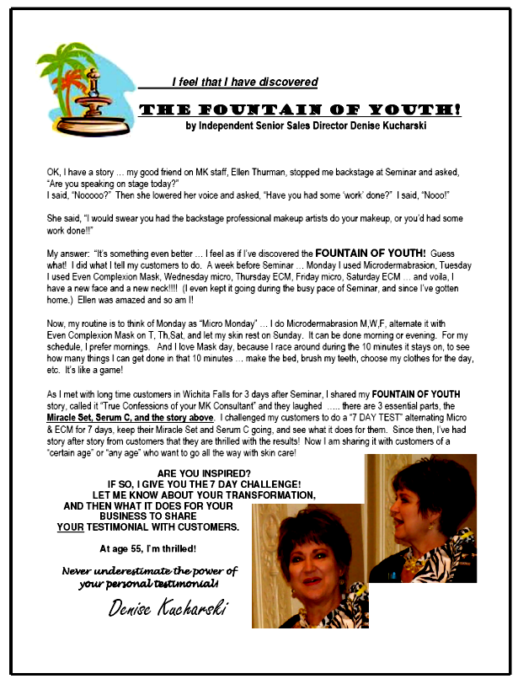
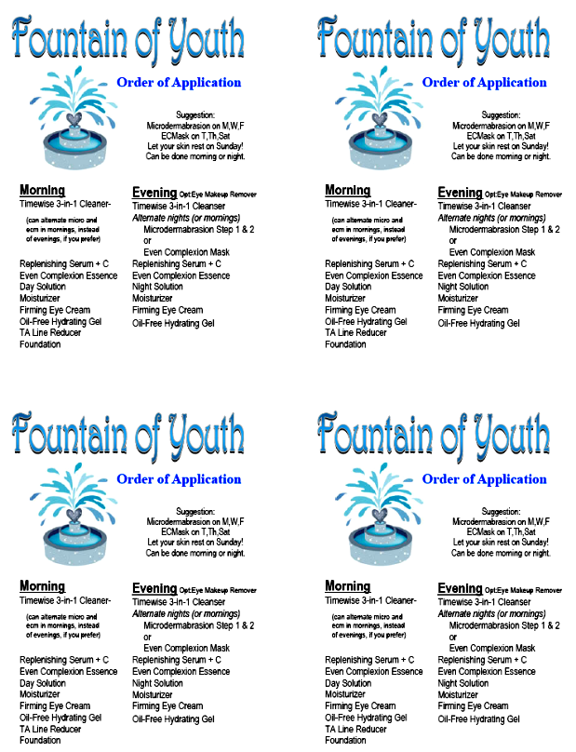
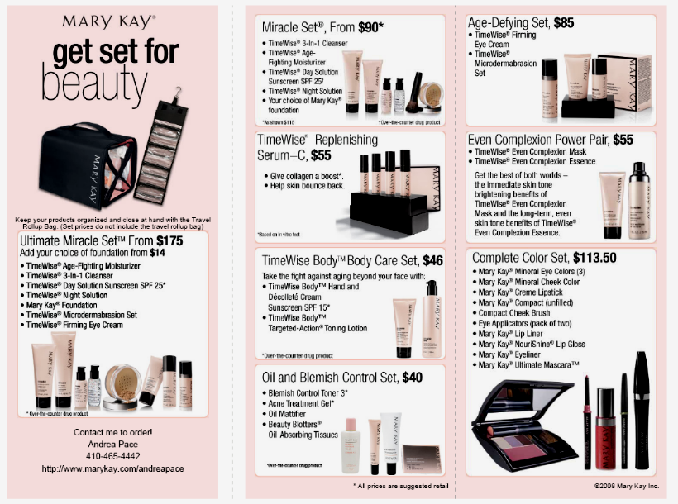


November Prize Promotion
“Pandora”Look alike Bracelet & Beads
(Inspired by Pandora Bracelets. Bead selection will vary from above pictured example.)
1 Bead 2 Beads 3 Beads 4 Beads 5 Beads
$250 Whls. $400 Whls. $600 Whls. $800 Whls. $1,000 Whls.
ALSO
Receive a bead for each active team member you bring in. (Active = $200 whls. order in the same month as her agreement went in.
Receive 3 Beads for Completing Star Consultant by December 15th, 2010.
Have you seen these EXPENSIVE but beautiful bracelets? Would you LOVE to have your own? Well, now you can! Starting in the month of October, you can win your bracelet and begin to fill it up with these fabulous beads throughout this Seminar year. WOW! Build – A – Bracelet! Build – A – Business!

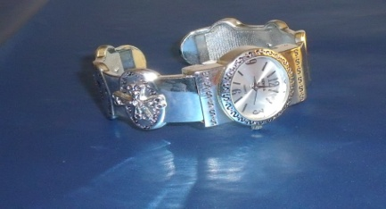
Keep a record of your Shows or Parties you Hold this Seminar Year. On holding your 10th Show, you will receive this beautiful Silver Inspirational Bracelet Watch. Just do this in this Seminar Year. Let’s all help Ryan Rogers, Mary Kay’s Grandson, reach our company Goal of 5 Billion in Sales by 2013. All you have to do is just call me and say “I DID IT!”

$1,000 Wholesale –Moreno Glass Dark Blue Heart Set– Kay Childers
$600 Wholesale –2 Glass Bracelets– Phyllis Jones and Eileen Hanson
$450 Wholesale – Jackie Hatcher
$250 Wholesale – Taffee Anhder, Donna Canada, Sharon Edwards, LaRon Fulbright, Bonnie Hobson,
Gloria McCutcheon, Ellen Wallace, and Joker Ward
Star Consultant Purse Winners: Judi Liles, Eileen Hanson, Jackie Hatcher, and Kay Childers

Happy Birthday
November Day
Kathi Heering 1
Brenda Green 3
Ruby F. Hulett 16
Sandra Gutierrez 17
Jana R. Morgan 19
Betty M. Everett 20
C R. Akins 27

Mary Kay Anniversary
November Years
Lynn Leonard 36
Christine T Castioni 29
Joyce M. Foster 24
Judith F. Weiner 22
Eileen Hanson 22
B.J. Watson 17
Nancy Sweet 16
Bobbie L. Merritt 16
Mary L. Welter 16
Claudia K. Tufano 16
Sharon L. Dixon 12
Phyllis A. Jones 7
Cynthia J. Ostermann 5
Elisabeth Scott 1

Your Guide to What’s Inside
November Hall of Fame (page1)
SeptemberScoreboard (page 2)
Recruiter & their Teams (page 3)
Star Status/Dear Angels (page 4)
New Time Wise Liquid Foundations are Coming (p5)
Fountain of Youth Story (page 6)
Order of Application (page 7)
Get Set For Beauty (page 8)

Nov. Promo/Prizes Won (p. 9)
Birthdays/Anniversaries (page 10)

You can now start signing up for the Preferred Customer Program. The deadline to enroll is November 15, 2010.

Andrea Pace, Future Executive Senior Sales Director
4206 Southfield Road
Ellicott City, Maryland 21042-5906
(410) 465-4442 or 1-800-863-2463
Fax No. (410) 313-9294; Cell Phone: (443) 980-7353
E-Mail Address – andrea@andreapace.com
Web Site for Andrea’s Consultants:
http://www.andreapace.com
Customer Website:
http://www.marykay.com/andreapace

“But if people want to brag, let them brag that they understand and know me. Let them brag that I am the Lord, and that I am kind and fair, and that I do things that are right on earth. This kind of bragging pleases me,” says the Lord.” Jeremiah 9:24

